 

## SPECIFIC ABSORPTION RATE CAUTIONER USING ANDROID

#### A PROJECT REPORT

***Submitted by***

**EZHILARASU.N [REGISTER NO:211417104061] GOKUL.N [REGISTER NO: 211417104069]**

**HARIHARAN.D [REGISTER NO: 211416104074]**

***in partial fulfillment for the award of the degree of***

### BACHELOR OF ENGINEERING

**IN**

#### COMPUTER SCIENCE ANDENGINEERING

**PANIMALAR ENGINEERING COLLEGE, CHENNAI-600123.**

**ANNA UNIVERSITY: CHENNAI 600 025**

**APRIL 2021**

**BONAFIDE CERTIFICATE**

Certified that this project report **“SPECIFIC ABSORPTION RATE CAUTIONER USING ANDROID”** is the bonafide work of **“EZHILARASU.N (2017PECCS389), GOKUL.N (2017PECCS394), HARIHARAN.D (2017PECCS399) ”** who carried out the project work under my supervision.

#### SIGNATURE SIGNATURE

**Dr.S.MURUGAVALLI,M.E.,Ph.D., Mr. M.MOHAN,M.Tech.,(Ph.D.), HEAD OFTHEDEPARTMENT ASSISTANT PROFESSOR(GRADE-I),** DEPARTMENTOFCSE, DEPARTMENT OFCSE,

PANIMALARENGINEERINGCOLLEGE, PANIMALAR ENGINEERING COLLEGE, NAZARATHPETTAI, NAZARATHPETTAI,

POONAMALLEE, POONAMALLEE,

CHENNAI-600123. CHENNAI-600 123.

Certified that the above candidate(s) was/ were examined in the Anna University Project Viva-Voce Examination held on 00.00.2021

#### INTERNALEXAMINER EXTERNAL EXAMINER

**ACKNOWLEDGEMENT**

We express our deep gratitude to our respected Secretary and Correspondent **Dr.P.CHINNADURAI, M.A., Ph.D.** for his kind words and enthusiastic motivation, which inspired us a lot in completing this project.

We would like to extend our heartfelt and sincere thanks to our Directors

**Tmt.C.VIJAYARAJESWARI**, **Thiru.C.SAKTHIKUMAR,M.E.,** and

**Tmt. SARANYASREE SAKTHIKUMAR B.E., M.B.A.,** for providing us with the necessary facilities for completion of this project.

We also express our gratitude to our Principal **Dr.K.Mani, M.E., Ph.D.** for his timely concern and encouragement provided to us throughout the course.

We thank the HOD of CSE Department, **Dr. S.MURUGAVALLI , M.E., Ph.D.,**

for the support extended throughout the project.

We would like to thank my **Project Guide Mr.M.Mohan,M.Tech.,(Ph.D.)** and all the faculty members of the Department of CSE for their advice and suggestions for the successful completion of the project.

EZHILARASU. N, GOKUL. N,

HARIHARAN. D.

## ABSTRACT

The EM radiation is measured based on Specific Absorption Rate (SAR). The human

head is generally exposed to mobile phones operating at communication (GSM, CDMA)

frequency bands. The radiation absorption analyzed through simulations by applying

frequency domain. The specific absorption rate (SAR) was measured for different

positions of mobile phone. SARs exhibited in much lower values as the mobile phone

held in far position from human brain.

In order to make it easier and compact we came up with a software application that can monitor the Specific Absorption Rate through call history and time duration of each call connecting with sensors and accelerometers. We have set defined SAR to calculate the Emission rate and caution the same to the user. In future as the usage of mobile phones is going to increase. Education platforms are going to switch over to digital forms. This application will help the younger generation to be aware of radiation passing through their body.

### LIST OF FIGURES

|  |  |  |
| --- | --- | --- |
| **CHAPTER NO.** | **TITLE** | **PAGE NO.** |
| **4.** | **SYSTEM DESIGN** |  |
|  | 4.1. ER-Diagram | 25 |
|  | 4.2. Data Flow Diagram of Doctor | 28 |
|  | 4.3. Data Flow Diagram of Patient | 28 |
|  | 4.4. Use Case Diagram | 33 |
|  | 4.5. Class Diagram | 34 |
|  | 4.6 Sequence Diagram | 35 |
|  | 4.7 Timeline Chart | 36 |
| 5. | SYSTEM ARCHITECTURE |  |
|  | 5.1. System Architecture | 38 |

**LIST OF TABLES**

|  |  |  |
| --- | --- | --- |
| **CHAPTER NO.** | **TITLE** | **PAGE NO.** |
| **3.** | **SYSTEM ANALYSIS** |  |
|  | 3.1. Minimum Hardware Requirements | 13 |
|  | 3.2. Minimum Software Requirements | 13 |
| **4.** | **SYSTEM DESIGN** |  |
|  | 4.1. Data Dictionary of User | 26 |
| **6.** | **SYSTEM TESTING** |  |
|  | 6.1. Test Case for User Module | 46 |
|  | 6.2. Test Case for Knowledge System | 47 |
|  | 6.3. Test Case for Doctor Module | 47 |

**TABLE OF CONTENTS**

|  |  |  |
| --- | --- | --- |
| **CHAPTER NO.** | **TITLE** | **PAGE NO.** |
|  | **ABSTRACT** | iv |
| **1.** | **INTRODUCTION** | 1 |
|  | 1.1 Overview | 2 |
| **2.** | **LITERATURE SURVEY** | 4 |
| **3.** | **SYSTEM ANALYSIS** | 10 |
|  | 3.1 Existing System | 11 |
|  | 3.2 Proposed system | 11 |
|  | 3.3 Requirement Analysis and Specification | 11 |
|  | 3.3.1 Input Requirements | 12 |
|  | 3.3.2 Output Requirements | 12 |
|  | 3.3.3 Functional Requirements | 12 |
|  | 3.4 Feasibility Study | 12 |
|  | 3.4.1 Technical Feasibility | 12 |
|  | 3.4.2 Economic Feasibility | 12 |
|  | 3.5 Hardware Environment | 13 |
|  | 3.6 Software Environment | 13 |
|  | 3.7 Software Specification | 14 |

|  |  |  |
| --- | --- | --- |
| **CHAPTER NO.** | **TITLE** | **PAGE NO.** |
| **4.** | **SYSTEM DESIGN** | 24 |
|  | 4.1. ER diagram | 25 |
|  | 4.2 Data dictionary | 25 |
|  | 4.3 Data Flow Diagram | 27 |
|  | 4.4 UML Diagrams | 29 |
| **5.** | **SYSTEM ARCHITECTURE** | 37 |
|  | 5.1 Architecture Overview | 38 |
|  | 5.2 Module Design Specification | 38 |
|  | 5.2.1 Module Explanation | 39 |
|  | 5.3 Program Design Language | 40 |
| **6.** | **TESTING** | 43 |
|  | 6.1 System Testing | 44 |
|  | 6.2 Unit Testing | 45 |
|  | 6.3 Test Cases & Reports / Performance Analysis | 46 |
| **7.** | **CONCLUSION** | 48 |
|  | 7.1 Conclusion and Future Enhancements | 49 |
|  | **APPENDICES** |  |
|  | A.1 Sample Screens | 50 |
|  | A.1 Sample Code | 54 |
|  | **REFERENCES** | 93 |

**CHAPTER 1 INTRODUCTION**

**1.1 OVERVIEW**

There is considerable confusion and misunderstanding about the meaning of the maximum reported Specific Absorption Rate (SAR) values for cell phones (and other wireless devices). SAR is a measure of the rate of RF (radiofrequency) energy absorption by the body from the source being measured – in this case, a cell phone.

When measuring the SAR due to a mobile phone the phone is placed against a representation of a human head (a "SAR Phantom") in a talk position. The SAR value is then measured at the location that has the highest absorption rate in the entire head, which in the case of a mobile phone is often as close to the phone's antenna as possible. Measurements are made for different positions on both sides of the head and at different frequencies representing the frequency bands at which the device can transmit. Depending on the size and capabilities of the phone, additional testing may also be required to represent usage of the device while placed close to the user's body and/or extremities. Various governments have defined maximum SAR levels for RF energy emitted by mobile devices.

In order to make it easier and compact we came up with a software application that can monitor the Specific Absorption Rate through call history and time duration of each call connecting with sensors and accelerometers. We have set defined SAR to calculate the Emission rate and caution the same to the user. In future as the usage of mobile phones is going to increase. Education platforms are going to switch over to digital forms. This application will help the younger generation to be aware of radiation passing through their body.

Incase if the user has not check the SAR value, the system will remind the user regarding the SAR value. If the user follows the instruction of the system properly, everything will be fine. Otherwise the corresponding user will be notified regarding the report generated by system about the SAR value.

And the application provides an easy access and easy monitor over all the SAR value by the app. And this app can also notify the user about overall SAR value with call log. Thus the application creates a awareness and the user will be aware of the SAR value

# CHAPTER 2 LITERATURE SURVEY

#### Rigorous Analysis and Evaluation of Specific Absorption Rate (SAR) for Mobile

#### Multimedia Healthcare

#### Ghufran Ahmed, Saif Ul Islam, Maham Shahid, Adnan Akhunzada, Sohail Jabbar,

#### Muhammad Khurram Khan, Muhammad Riaz, And Kijun Han

Ghufran Ahmed, Saif Ul Islam, Maham Shahid, Adnan Akhunzada, Sohail Jabbar, Muhammad Khurram Khan, Muhammad Riaz, And Kijun Han in their research mobile multimedia applications transfer multimedia data and generate huge amount of data. Due to the high data rate, heat generated from sensor devices is considerably high and results in thermal dissipation. This heat generated from nodes may result in sensitive tissue damage. Hence, to avoid any damage to body organs there is a need to analyze SAR. In this paper, an extensive analysis of SAR is provided. More over, a comprehensive overview of safety aspects and challenges is also elaborated. As discussed earlier, the tissues of a human body are sensitive to heat. Therefore, thermal impact of IoT devices must be considered while designing WBAN solutions in order to mitigate the risk of tissue damage. SAR is affected by various factors like change in the distance between node sand the current provided to nodes’ antenna. The position of the sink is also an important parameter for SAR. In this paper, all these aspects are evaluated rigorously.

#### A Review on SAR Reduction Methods Used For Mobile Application

#### Dhanesh.P, Jayesh George. M, Anoop.B.K

Dhanesh.P, Jayesh George. M, Anoop.B.K presents a study of different methods used for specific absorption rate (SAR) reduction and factors depending on the SAR value for mobile application. The presented studies provide useful information for future design of mobile handset antennas. The Size, position of the antenna, material used and some other parameters also decides SAR value. According to standardization regulation committee in different region SAR value should be maintained in any mobile phones. So that SAR value is a crucial point in antenna design. The studies on the SAR reduction methods for mobile application reveal the idea for designing healthy antenna's for mobile application. The efficient method to reduce the SAR is designing of meta materials. Size, position, thickness of an antenna also matters in case of SAR. SAR value is a important parameter in case of mobile devices. SAR is also a crucial parameter in antenna design.

#### The study of specific absorption rate (SAR) reduction in mobile phones using

#### materials and metamaterials.

#### Mohammad Rashed Iqbal Faruque, Mohammad Tariqul Islamand Norbahiah

#### Misran

#### Mohammad Rashed Iqbal Faruque, Mohammad Tariqul Islam and Norbahiah

Misran researched an reducing of specific absorption rate (SAR) with materials and meta materials attachment is investigated. The finite-difference time-domain method with lossy-Drude model is adopted in this study. The methodology of SAR reduction is addressed and the belongings of attaching position, distance, and size of ferrite sheet material properties, perfect electric conductor (PEC), and meta materials on the SAR reduction are investigated. Materials have achieved a 47.02% reduction of the initial SAR value while metamaterials achieved a reduction of 49.21% respectively for the case of 1 g SAR. These results propose a guideline to decide assorted types of materials and metamaterials with the utmost SAR reducing effect for a phone model. The EM interaction between an antenna and the human head with materials and metamaterials has been discussed in this paper. Utilizing material in the phone model, a SAR value achieved about 0.676 W/kg for SAR 10 g and with metamaterial, a SAR value of 0.737 W/kg for SAR 10 g is achieved. Based on the 3-D FDTD method with lossy-Drude model, it is found that the peak SAR 1 g of the head can be reduced by placing materials and metamaterials between the antenna and the human head. Metamaterials were designed from a periodic arrangement of SRRS. Numerical results can provide useful information in designing communication equipment for safety compliance.

# CHAPTER 3 SYSTEM ANALYSIS

### EXISTING SYSTEM

Existing Mobile phone radiation monitoring system gives only the Specific Absorption Rate of the particular mobile phone. It does not caution the user when connected to charging mode.

### PROPOSEDSYSTEM

* + 1. To guide the user and caution the user to know the amount of radiation emitted and passes through the brain.
    2. This application also cautions the user when connected in charging mode to unplug and attend calls.

Advantages

* + - 1. It gives awareness of how much radiation has passed through their body.
      2. It also cautions the user when connected to charging mode.

### REQUIREMENT ANALYSIS ANDSPECIFICAITON

The requirement engineering process of feasibility study, requirements elicitation and analysis, requirement specification, requirements validation and requirement management. Requirement elicitation and analysis is an iterative process that can be represented as a spiral of activities, namely requirements discovery, requirements classification and organization, requirement negotiation and requirements documentation.

### INPUT REQUIREMENT

The input requirement at the base requires data from the user that can be taken automatically from the user call log. These data is then processed and the SAR value is given.

### OUTPUTREQUIREMENT

The output things necessary for these are a database for storing and manipulation of user data and a knowledge mobile OS for manipulation of Call log data and sending appropriate notification for the respective person.

### FEASIBILITYSTUDY

A feasibility study is carried out to select the best system that meets performance requirements. The main aim of the feasibility study activity is to determine that it would be financially and technically feasible to develop the product.

### TECHNICALFEASIBILITY

This is concerned with specifying the software will successfully satisfy the user requirement. Open source and business-friendly and it is truly cross platform, easily deployed and highly extensible.

### ECONOMICFEASIBILITY

Economic analysis is the most frequently used technique for evaluating the

effectiveness of a proposed system. The enhancement of the existing system doesn’t incur any kind of increase in the expenses. Programming Language for Android App development is open source and readily available for all users. Since, the project is running in the Android Studio, hence it is cost efficient.

### MINIMUM HARDWAREREQUIREMENTS

|  |  |
| --- | --- |
| Processor | Core i3, 2.4 GHz |
| Hard disk | 500 GB |
| RAM | 4GB |
| Monitor | 14/15 inches Color |

* 1. **SOFTWARE REQUIEMENTS**

|  |  |
| --- | --- |
| Development Environment | Android Studio 4.1.3 |
| Front End Language | Xml |
| Back-End Language | Java |

|  |  |
| --- | --- |
| Database | SQLite |

* 1. **SOFTWARE SPECIFICATION**

#### XML

Extensible Markup Language (XML) is a [markup language](https://en.wikipedia.org/wiki/Markup_language) that defines a set of rules for encoding [documents](https://en.wikipedia.org/wiki/Electronic_document) in a [format](https://en.wikipedia.org/wiki/File_format) that is both [human-readable](https://en.wikipedia.org/wiki/Human-readable_medium) and [machine-readable](https://en.wikipedia.org/wiki/Machine-readable_data). The [World Wide Web Consortium](https://en.wikipedia.org/wiki/World_Wide_Web_Consortium)'s XML 1.0 Specification of 1998 and several other related specifications—all of them free [open standards](https://en.wikipedia.org/wiki/Open_standard)—define XML.

The design goals of XML emphasize simplicity, generality, and usability across the [Internet](https://en.wikipedia.org/wiki/Internet). It is a textual data format with strong support via [Unicode](https://en.wikipedia.org/wiki/Unicode) for different [human languages](https://en.wikipedia.org/wiki/Language). Although the design of XML focuses on documents, the language is widely used for the representation of arbitrary [data structures](https://en.wikipedia.org/wiki/Data_structure) such as those used in [web services](https://en.wikipedia.org/wiki/Web_service).

Several [schema systems](https://en.wikipedia.org/wiki/XML_schema) exist to aid in the definition of XML-based languages, while programmers have developed many [application programming interfaces](https://en.wikipedia.org/wiki/Application_programming_interface) (APIs) to aid the processing of XML data.

**XML Application**

XML is an extension of .xml. Hundreds of document formats using XML syntax have been developed,[[8]](https://en.wikipedia.org/wiki/XML#cite_note-Cover_pages_list-8) including [RSS](https://en.wikipedia.org/wiki/RSS), [Atom](https://en.wikipedia.org/wiki/Atom_(standard)), [SOAP](https://en.wikipedia.org/wiki/SOAP), [SVG](https://en.wikipedia.org/wiki/Scalable_Vector_Graphics), and [XHTML](https://en.wikipedia.org/wiki/XHTML). XML-based formats have become the default for many office-productivity tools, including [Microsoft Office](https://en.wikipedia.org/wiki/Microsoft_Office) ([Office Open XML](https://en.wikipedia.org/wiki/Office_Open_XML)), [OpenOffice.org](https://en.wikipedia.org/wiki/OpenOffice.org) and [LibreOffice](https://en.wikipedia.org/wiki/LibreOffice) ([OpenDocument](https://en.wikipedia.org/wiki/OpenDocument)), and [Apple](https://en.wikipedia.org/wiki/Apple_Computer)'s [iWork](https://en.wikipedia.org/wiki/IWork). XML has also provided the base language for [communication protocols](https://en.wikipedia.org/wiki/Communication_protocol) such as [XMPP](https://en.wikipedia.org/wiki/Extensible_Messaging_and_Presence_Protocol). Applications for the [Microsoft](https://en.wikipedia.org/wiki/Microsoft)[.NET Framework](https://en.wikipedia.org/wiki/.NET_Framework) use XML files for configuration, and [property lists](https://en.wikipedia.org/wiki/Property_list) are an implementation of configuration storage built on XML.[[9]](https://en.wikipedia.org/wiki/XML#cite_note-9)

Many industry data standards, such as [Health Level 7](https://en.wikipedia.org/wiki/Health_Level_7), [OpenTravel Alliance](https://en.wikipedia.org/wiki/OpenTravel_Alliance), [FpML](https://en.wikipedia.org/wiki/FpML), [MISMO](https://en.wikipedia.org/wiki/MISMO), and [National Information Exchange Model](https://en.wikipedia.org/wiki/National_Information_Exchange_Model) are based on XML and the rich features of the XML schema specification. Many of these standards are quite complex and it is not uncommon for a specification to comprise several thousand pages.[*[citation needed](https://en.wikipedia.org/wiki/Wikipedia:Citation_needed" \o "Wikipedia:Citation needed)*] In publishing, [Darwin Information Typing Architecture](https://en.wikipedia.org/wiki/Darwin_Information_Typing_Architecture) is an XML industry data standard. XML is used extensively to underpin various publishing formats.

XML is widely used in a [Service-oriented architecture](https://en.wikipedia.org/wiki/Service-oriented_architecture) (SOA). Disparate systems communicate with each other by exchanging XML messages. The message exchange format is standardised as an [XML schema](https://en.wikipedia.org/wiki/XML_schema) (XSD). This is also referred to as the canonical schema. XML has come into common use for the interchange of data over the Internet. [IETF](https://en.wikipedia.org/wiki/History_of_the_Internet#Internet_Engineering_Task_Force)[RFC:3023](https://tools.ietf.org/html/rfc3023), now superseded by [RFC:7303](https://tools.ietf.org/html/rfc7303), gave rules for the construction of [Internet Media Types](https://en.wikipedia.org/wiki/Internet_media_type) for use when sending XML. It also defines the media types application/xml and text/xml, which say only that the data is in XML, and nothing about its [semantics](https://en.wikipedia.org/wiki/Semantics).

#### HTML

Hypertext Markup Language (HTML) is the standard markup language for documents designed to be displayed in a web browser. It can be assisted by technologies such as Cascading Style Sheets (CSS) and scripting languages such as JavaScript.

[Web browsers](https://en.wikipedia.org/wiki/Web_browser) receive HTML documents from a [web server](https://en.wikipedia.org/wiki/Web_server) or from local storage and [render](https://en.wikipedia.org/wiki/Browser_engine) the documents into multimedia web pages. HTML describes the structure of a web page [semantically](https://en.wikipedia.org/wiki/Semantic_Web) and originally included cues for the appearance of the document.

[HTML elements](https://en.wikipedia.org/wiki/HTML_element) are the building blocks of HTML pages. With HTML constructs, [images](https://en.wikipedia.org/wiki/HTML_element#Images_and_objects) and other objects such as [interactive forms](https://en.wikipedia.org/wiki/Fieldset) may be embedded into the rendered page. HTML provides a means to create [structured documents](https://en.wikipedia.org/wiki/Structured_document) by denoting structural [semantics](https://en.wikipedia.org/wiki/Semantics) for text such as headings, paragraphs, lists, [links](https://en.wikipedia.org/wiki/Hyperlink), quotes and other items. HTML elements are delineated by *tags*, written using [anglebrackets](https://en.wikipedia.org/wiki/Bracket#Angle_brackets). Tags such as <img /> and <input /> directly introduce content into the page. Other tags such as <p> surround and provide information aboutdocumenttext and may include other tags as sub-elements. Browsers do not display the HTML tags, but use them to interpret the content of the page.

HTML can embed programs written in a [scripting language](https://en.wikipedia.org/wiki/Scripting_language) such as [JavaScript](https://en.wikipedia.org/wiki/JavaScript), which affects the behavior and content of web pages. Inclusion of CSS defines the look and layout of content. The [World Wide Web Consortium](https://en.wikipedia.org/wiki/World_Wide_Web_Consortium) (W3C), former maintainer of the HTML and current maintainer of the CSS standards, has encouraged the use of CSS over explicit presentational HTML since 1997.

HTML markup consists of several key components, including those called *tags* (and their attributes), character-based data types, character referencesandentityreferences.HTMLtagsmostcommonlycomeinpairslike

<h1> and </h1>, although some represent empty elements and so are unpaired, for example <img>. The first tag in such a pair is the start tag, and the second is the end tag (they are also called opening tags and closingtags).

HTML documents imply a structure of nested [HTML elements](https://en.wikipedia.org/wiki/HTML_element). These are indicated in the document by HTML tags, enclosed in angle brackets thus:

In the simple, general case, the extent of an element is indicated by a pair of tags: a "start tag" <p> and "end tag"</p>. The text content of the element, if any, is placed between these tags.

#### HTMLApplication

An HTML Application (HTA; file extension ".hta") is a [Microsoft](https://en.wikipedia.org/wiki/Microsoft_Windows) [Windows](https://en.wikipedia.org/wiki/Microsoft_Windows) application that uses HTML and Dynamic HTML in a [browser](https://en.wikipedia.org/wiki/Web_browser) to provide the application's graphical interface. A regular HTML file is confined to the security model of the [web browser's security](https://en.wikipedia.org/wiki/Browser_security), communicating only to web servers and manipulating only web page objects and [site cookies](https://en.wikipedia.org/wiki/HTTP_cookie). An HTA runs as afullytrustedapplicationandthereforehasmoreprivileges,likecreation/editing/removal of files and [Windows Registry](https://en.wikipedia.org/wiki/Windows_Registry) entries. Because they operate outside the browser's security model, HTAs cannot be executed via HTTP, but must be downloaded (just like an [EXE file](https://en.wikipedia.org/wiki/EXE)) and executed from the local file system.

Tags may also enclose further tag markup between the start and end, including a mixture of tags and text. This indicates further (nested) elements, as children of the parent element.

The start tag may also include attributes within the tag. These indicate other information, such as identifiers for sections within the document, identifiers used to bind style information to the presentation of the document, and for some tags such as the <img> used to embed images, the reference to the image resource.

### CSS

* + - 1. **INTRODUCTION**

Cascading Style Sheets (CSS) is a [style sheet language](https://en.wikipedia.org/wiki/Style_sheet_language) used for describing the [presentation](https://en.wikipedia.org/wiki/Presentation_semantics) of a document written in a [markup language](https://en.wikipedia.org/wiki/Markup_language) like [HTML](https://en.wikipedia.org/wiki/HTML). CSS is a cornerstone technology of the [World Wide Web](https://en.wikipedia.org/wiki/World_Wide_Web), alongside HTML and [JavaScript](https://en.wikipedia.org/wiki/JavaScript). CSS is designed to enable the separation of presentation and content, including [layout](https://en.wikipedia.org/wiki/Page_layout), [colors](https://en.wikipedia.org/wiki/Color), and [fonts](https://en.wikipedia.org/wiki/Typeface). This separation can improve content [accessibility](https://en.wikipedia.org/wiki/Accessibility), provide more flexibility and control in the specification of presentation characteristics, enable multiple [web pages](https://en.wikipedia.org/wiki/Web_page) to share formatting by specifying the relevant CSS in a separate .css file, and reduce complexity and repetition in the structural content.

Separation of formatting and content also makes it possible to present the same markup page in different styles for different rendering methods, such ason-screen,

in print, by voice (via speech-based browser or [screen reader](https://en.wikipedia.org/wiki/Screen_reader)), and on [Braille-based](https://en.wikipedia.org/wiki/Braille_display) tactile devices. CSS also has rules for alternate formatting if the content is accessed on a [mobiledevice](https://en.wikipedia.org/wiki/Mobile_device).

The name *cascading* comes from the specified priority scheme to determine which style rule applies if more than one rule matches a particular element. This cascading priority scheme is predictable.

The CSS specifications are maintained by the [World Wide Web](https://en.wikipedia.org/wiki/World_Wide_Web_Consortium) [Consortium](https://en.wikipedia.org/wiki/World_Wide_Web_Consortium) (W3C). Internet media type ([MIME type](https://en.wikipedia.org/wiki/MIME_media_type)) text/css is registered for use with CSS by [RFC 2318](https://tools.ietf.org/html/rfc2318) (March 1998). The W3C operates a free [CSS validation](https://en.wikipedia.org/wiki/W3C_Markup_Validation_Service#CSS_validation) [service](https://en.wikipedia.org/wiki/W3C_Markup_Validation_Service#CSS_validation) for CSS documents. In addition to HTML, other markup languages support the use of CSS including [XHTML](https://en.wikipedia.org/wiki/XHTML), [plain XML](https://en.wikipedia.org/wiki/Plain_Old_XML), [SVG](https://en.wikipedia.org/wiki/Scalable_Vector_Graphics), and [XUL](https://en.wikipedia.org/wiki/XUL).

#### USE OF CSS

Before CSS, nearly all presentational attributes of HTML documents were contained within the HTML markup. All font colors, background styles, element alignments, borders and sizes had to be explicitly described, often repeatedly, within the HTML. CSS let's authors move much of that information to another file, the style sheet, resulting in considerably simpler HTML.

For example, headings (h1 elements), sub-headings (h2), sub-sub-headings (h3), etc., are defined structurally using HTML. In print and on the screen, the choice of [font](https://en.wikipedia.org/wiki/Typeface), [size](https://en.wikipedia.org/wiki/Point_(typography)), [color](https://en.wikipedia.org/wiki/Color) and [emphasis](https://en.wikipedia.org/wiki/Emphasis_(typography)) for these elements is presentational.

Before CSS, document authors who wanted to assign such [typographic](https://en.wikipedia.org/wiki/Typography) characteristics to, say, all h2 headings had to repeat HTML presentational markup for each occurrence of that heading type. This made documents more complex, larger, and more error-prone and difficult to maintain. CSS allows the separation of presentation from structure. CSS can define color, font, text alignment, size, borders, spacing, layout and many other typographic

characteristics, and can do so independently for on-screen and printed views. CSS also defines non-visual styles, such as reading speed and emphasis for aural text readers. The [W3C](https://en.wikipedia.org/wiki/W3C) has now [deprecated](https://en.wikipedia.org/wiki/Deprecation) the use of all presentational HTML markup.

### SQLite

SQLite is an in-process library that implements a [self-contained](https://www.sqlite.org/selfcontained.html), [serverless](https://www.sqlite.org/serverless.html), [zero-configuration](https://www.sqlite.org/zeroconf.html), [transactional](https://www.sqlite.org/transactional.html) SQL database engine. The code for SQLite is in the [public domain](https://www.sqlite.org/copyright.html) and is thus free for use for any purpose, commercial or private. SQLite is the [most widely deployed](https://www.sqlite.org/mostdeployed.html) database in the world with more applications than we can count, including several [high-profile projects.](https://www.sqlite.org/famous.html)

SQLite is an embedded SQL database engine. Unlike most other SQL databases, SQLite does not have a separate server process. SQLite reads and writes directly to ordinary disk files. A complete SQL database with multiple tables, indices, triggers, and views, is contained in a single disk file. The database [file format](https://www.sqlite.org/fileformat2.html) is cross-platform - you can freely copy a database between 32-bit and 64-bit systems or between [big-endian](http://en.wikipedia.org/wiki/Endianness) and [little-endian](http://en.wikipedia.org/wiki/Endianness) architectures. These features make SQLite a popular choice as an [Application File Format](https://www.sqlite.org/appfileformat.html). SQLite database files are a [recommended storage format](https://www.sqlite.org/locrsf.html) by the US Library of Congress. Think of SQLite not as a replacement for [Oracle](http://www.oracle.com/database/index.html) but as a replacement for [fopen()](http://man.he.net/man3/fopen)

SQLite is a compact library. With all features enabled, the [library size](https://www.sqlite.org/footprint.html) can be less than 600KiB, depending on the target platform and compiler optimization settings. (64-bit code is larger. And some compiler optimizations such as aggressive function inlining and loop unrolling can cause the object code to be much larger.) There is a tradeoff between memory usage and speed. SQLite generally runs faster the more memory you give it. Nevertheless, performance is usually quite good even in low-memory environments. Depending on how it is used, SQLite can be [faster than direct filesystem I/O](https://www.sqlite.org/fasterthanfs.html).

### Java

**Java** is a [class-based](https://en.wikipedia.org/wiki/Class-based_programming), [object-oriented](https://en.wikipedia.org/wiki/Object-oriented_programming)[High level programming language](https://en.wikipedia.org/wiki/High-level_programming_language) that is designed to have as few implementation [dependencies](https://en.wikipedia.org/wiki/Dependency_(computer_science)) as possible. It is a [general-purpose](https://en.wikipedia.org/wiki/General-purpose_language) programming language intended to let [application developers](https://en.wikipedia.org/wiki/Application_developer)*write once, run anywhere* (WORA),[[16]](https://en.wikipedia.org/wiki/Java_(programming_language)#cite_note-16) meaning that [compiled](https://en.wikipedia.org/wiki/Compiler) Java code can run on all platforms that support Java without the need for recompilation.[[17]](https://en.wikipedia.org/wiki/Java_(programming_language)#cite_note-design_goals-17) Java applications are typically compiled to [bytecode](https://en.wikipedia.org/wiki/Java_bytecode) that can run on any [Java virtual machine](https://en.wikipedia.org/wiki/Java_virtual_machine) (JVM) regardless of the underlying [computer architecture](https://en.wikipedia.org/wiki/Computer_architecture). The [syntax](https://en.wikipedia.org/wiki/Syntax_(programming_languages)) of [Java](https://en.wikipedia.org/wiki/Java_(software_platform)) is similar to [C](https://en.wikipedia.org/wiki/C_(programming_language)) and [C++](https://en.wikipedia.org/wiki/C%2B%2B), but has fewer [low-level](https://en.wikipedia.org/wiki/Low-level_programming_language) facilities than either of them. The Java runtime provides dynamic capabilities (such as reflection and runtime code modification) that are typically not available in traditional compiled languages.

There were five primary goals in the creation of the Java language:[[17]](https://en.wikipedia.org/wiki/Java_(programming_language)" \l "cite_note-design_goals-17)

* + - 1. It must be simple, [object-oriented](https://en.wikipedia.org/wiki/Object-oriented), and familiar.
      2. It must be robust and secure.
      3. It must be architecture-neutral and portable.
      4. It must execute with high performance.
      5. It must be [interpreted](https://en.wikipedia.org/wiki/Interpreted_language), [threaded](https://en.wikipedia.org/wiki/Thread_(computing)), and [dynamic](https://en.wikipedia.org/wiki/Dynamic).

**Java Syntax**

The syntax of Java is largely influenced by [C++](https://en.wikipedia.org/wiki/C%2B%2B) and [C](https://en.wikipedia.org/wiki/C_(programming_language)). Unlike C++, which combines the syntax for structured, generic, and object-oriented programming, Java was built almost exclusively as an object-oriented language.[[17]](https://en.wikipedia.org/wiki/Java_(programming_language)#cite_note-design_goals-17) All code is written inside classes, and every data item is an object, with the exception of the primitive data types, (i.e. integers, floating-point numbers, [boolean values](https://en.wikipedia.org/wiki/Boolean_data_type), and characters), which are not objects for performance reasons. Java reuses some popular aspects of C++.

**Java Android**

The Java language is a key pillar in [Android](https://en.wikipedia.org/wiki/Android_(operating_system)), an [open source](https://en.wikipedia.org/wiki/Open_source_software)[mobile operating system](https://en.wikipedia.org/wiki/Mobile_operating_system). Although Android, built on the [Linux kernel](https://en.wikipedia.org/wiki/Linux_kernel), is written largely in C, the [Android SDK](https://en.wikipedia.org/wiki/Android_software_development#SDK) uses the Java language as the basis for Android applications but does not use any of its standard GUI, SE, ME or other established Java standards.[[76]](https://en.wikipedia.org/wiki/Java_(programming_language)#cite_note-76) The bytecode language supported by the Android SDK is incompatible with Java bytecode and runs on its own virtual machine, optimized for low-memory devices such as [smartphones](https://en.wikipedia.org/wiki/Smartphone) and [tablet computers](https://en.wikipedia.org/wiki/Tablet_computer). Depending on the Android version, the bytecode is either interpreted by the [Dalvik virtual machine](https://en.wikipedia.org/wiki/Dalvik_(software)) or compiled into native code by the [Android Runtime](https://en.wikipedia.org/wiki/Android_Runtime).

Android does not provide the full Java SE standard library, although the Android SDK does include an independent implementation of a large subset of it. It supports Java 6 and some Java 7 features, offering an implementation compatible with the standard library

### JavaScript

**JavaScript** often abbreviated as **JS**, is a programming language that conforms to the [ECMAScript](https://en.wikipedia.org/wiki/ECMAScript) specification. JavaScript is [high-level](https://en.wikipedia.org/wiki/High-level_programming_language), often [just-in-timecompiled](https://en.wikipedia.org/wiki/Just-in-time_compilation), and [multi-paradigm](https://en.wikipedia.org/wiki/Programming_paradigm). It has [curly-bracket syntax](https://en.wikipedia.org/wiki/List_of_programming_languages_by_type#Curly-bracket_languages), [dynamictyping](https://en.wikipedia.org/wiki/Dynamic_typing), [prototype-based](https://en.wikipedia.org/wiki/Prototype-based_programming) [object-orientation](https://en.wikipedia.org/wiki/Object-oriented_programming), and [first-classfunctions](https://en.wikipedia.org/wiki/First-class_function).

Alongside [HTML](https://en.wikipedia.org/wiki/HTML) and [CSS](https://en.wikipedia.org/wiki/CSS), JavaScript is one of the core technologies of the [WorldWide Web](https://en.wikipedia.org/wiki/World_Wide_Web). JavaScript enables interactive [web pages](https://en.wikipedia.org/wiki/Web_page) and is an essential part of [web applications](https://en.wikipedia.org/wiki/Web_application). The vast majority of [websites](https://en.wikipedia.org/wiki/Website) use it for [client-side](https://en.wikipedia.org/wiki/Client-side) page behavior, and all major [web browsers](https://en.wikipedia.org/wiki/Web_browser) have a dedicated [JavaScript engine](https://en.wikipedia.org/wiki/JavaScript_engine) to executeit.

As a multi-paradigm language, JavaScript supports [event-driven](https://en.wikipedia.org/wiki/Event-driven_programming), [functional](https://en.wikipedia.org/wiki/Functional_programming), and [imperative](https://en.wikipedia.org/wiki/Imperative_programming) [programming styles](https://en.wikipedia.org/wiki/Programming_paradigm). It has [application programminginterfaces](https://en.wikipedia.org/wiki/Application_programming_interface) (APIs) for working with text, dates, [regular expressions](https://en.wikipedia.org/wiki/Regular_expression), standard [datastructures](https://en.wikipedia.org/wiki/Data_structure), and the [Document Object Model](https://en.wikipedia.org/wiki/Document_Object_Model) (DOM). However, the language itself does not include any [input/output](https://en.wikipedia.org/wiki/Input/output) (I/O), such as [networking](https://en.wikipedia.org/wiki/Computer_network), [storage](https://en.wikipedia.org/wiki/Data_storage), or [graphics](https://en.wikipedia.org/wiki/Computer_graphics) facilities, as the host environment (usually a web browser) provides thoseAPIs.

JavaScript engines were originally used only in web browsers, but they are now embedded in some [servers](https://en.wikipedia.org/wiki/Server_(computing)), usually via [Node.js](https://en.wikipedia.org/wiki/Node.js). They are also embedded in a variety of applications created with [frameworks](https://en.wikipedia.org/wiki/Software_framework) such as [Electron](https://en.wikipedia.org/wiki/Electron_(software_framework)) and [Cordova](https://en.wikipedia.org/wiki/Apache_Cordova).

Although there are similarities between JavaScript and [Java](https://en.wikipedia.org/wiki/Java_(programming_language)), including language name, [syntax](https://en.wikipedia.org/wiki/Syntax_(programming_languages)), and respective [standard libraries](https://en.wikipedia.org/wiki/Standard_library), the two languages are distinct and differ greatly in design.

# CHAPTER 4 SYSTEM DESIGN

### ER DIAGRAM FOR DIABETES GUIDANCESYSTEM

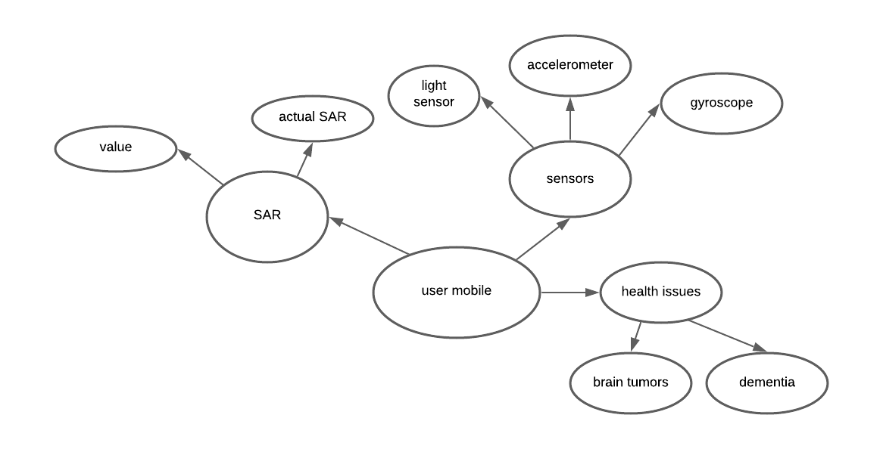

Fig 4.1 ER diagram

* 1. **DATADICTIONARY**

A data dictionary, or [metadata repository](https://en.wikipedia.org/wiki/Metadata_repository), as defined in the *IBM Dictionary of Computing*, is a "centralized repository of information about data such as meaning, relationships to other data, origin, usage, and format". [*Oracle*](https://en.wikipedia.org/wiki/Oracle_Corporation) defines it as a collection of tables with metadata. The term can have one of several closely related meanings pertaining to [databases](https://en.wikipedia.org/wiki/Database) and [database management systems](https://en.wikipedia.org/wiki/Database_management_system) (DBMS):

* A [document](https://en.wikipedia.org/wiki/Document) describing a database or collection of databases
* An integral [component](https://en.wikipedia.org/wiki/Software_component) of a [DBMS](https://en.wikipedia.org/wiki/Database_management_system) that is required to determine its structure
* A piece of [middleware](https://en.wikipedia.org/wiki/Middleware) that extends or supplants the native data dictionary of a DBMS

### User:

|  |  |
| --- | --- |
| **Field** | **Datatype** |
| **Call log** | **Int** |
| **SAR Value** | **Float** |
| **Health Issues** | **String** |

* 1. **DATA FLOWDIAGRAM**

A picture is worth a thousand words. A Data Flow Diagram (DFD) is traditional visual representation of the information flows within a system. A neat and clear DFD can depict a good amount of the system requirements graphically. It can be manual, automated, or combination of both. It shows how information enters and leaves the system, what changes the information and where information is stored. The purpose of a DFD is to show the scope and boundaries of a system as a whole. It may be used as a communications tool between a systems analyst and any person who plays a part in the system that acts as the starting point for redesigning a system.

It is usually beginning with a context diagram as the level 0 of DFD diagram, a simple representation of the whole system. To elaborate further from that, we drill down to a level 1 diagram with lower level functions decomposed from the major functions of the system. This could continue to evolve to become a level 2 diagram when further analysis is required. Progression to level 3, 4 and so on is possible but anything beyond level 3 is not very common. Please bear in mind that the level of details for decomposing function really depending on the complexity that function.

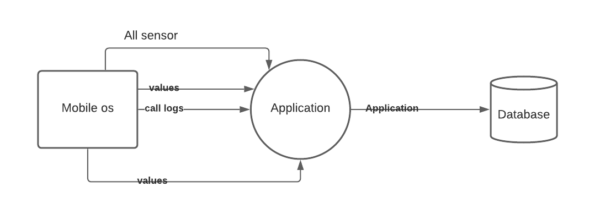

Fig 4.2 Data flow diagram of user

### UML DIAGRAMS

UML stands for Unified Modeling Language. It’s a rich language to model software solutions, application structures, system behavior and business processes. There are 14 UML diagram types to help you model these behaviors. Unified Modeling Language™ (UML®) is a standard visual modeling language intended to be used for

* modeling business and similar processes,
* analysis, design, and implementation of software-based systems

UML is a common language for business analysts, software architects and developers used to describe, specify, design, and document existing or new business processes, structure and behavior of artifacts of software systems.

Specification explained that process:

* provides guidance as to the order of a team activities,
* specifies what artifacts should be developed,
* directs the tasks of individual developers and the team as a whole, and
* offers criteria for monitoring and measuring a project’s products and activities.

UML is intentionally process independent and could be applied in the context of different processes. Still, it is most suitable for use case driven, iterative and incremental development processes. An example of such process is Rational Unified Process (RUP).UML is not complete, and it is not completely visual. Given some UML diagram, we can't be sure to understand depicted part or behavior of the system from the diagram alone. Some information could be

intentionally omitted from the diagram, some information represented on the diagram could have different interpretations, and some concepts of UML have no graphical notation at all, so there is no way to depict those on diagrams. For example, semantics of multiplicity of actors and multiplicity of use cases on use case diagrams is not defined precisely in the UML specification and could mean either concurrent or successive usage of use cases.

Name of an abstract classifier is shown in italics while final classifier has no specific graphical notation, so there is no way to determine whether classifier is final or not from the diagram.

#### List of UML Diagram Types

So, what are the different UML diagram types? There are two main categories; structure diagrams and behavioral diagrams. Click on the links to learn more about a specific diagram type.

#### Structure Diagrams

Structure diagrams show the things in the modeled system. In a more technical term, they show different objects in a system. Behavioral diagrams show what should happen in a system. They describe how the objects interact with each other to create a functioning system.

#### Class Diagram

Class diagrams are the main building block of any object-oriented solution. It shows the classes in a system, attributes, and operations of each class and the relationship between each class. In most modeling tools, a class has three parts. name at the top, attributes in the middle and operations or methods at the bottom. In a large system with many related classes, classes are grouped together to create class diagrams. Different relationships between classes are shown by different types of arrows.

#### Component Diagram

A component diagram displays the structural relationship of components of a software system. These are mostly used when working with complex systems with many components. Components communicate with each other using interfaces. The interfaces are linked using connectors. The image below shows a component diagram.

#### Deployment Diagram

A deployment diagram shows the hardware of your system and the software in that hardware. Deployment diagrams are useful when your software solution is deployed across multiple machines with each having a unique configuration. Below is an example deployment diagram.

#### Package Diagram

As the name suggests, a package diagram shows the dependencies between different packages in a system. Check out this wiki article to learn more about the dependencies and elements found in package diagrams.

#### Composite Structure Diagram

Composite structure diagrams are used to show the internal structure of a class. For a detailed explanation of composite structure diagrams, click here.

#### Use Case Diagram

As the most known diagram type of the behavioral UML diagrams, use case diagrams give a graphic overview of the actors involved in a system, different functions needed by those actors and how these different functions interact.

It’s a great starting point for any project discussion because you can easily identify the main actors involved and the main processes of the system. You can create use case diagrams using our tool and/or get started instantly using our use case templates.

#### Activity Diagram

Activity diagrams represent workflows in a graphical way. They can be used to describe the business workflow or the operational workflow of any component in a system. Sometimes activity diagrams are used as an alternative to State machine diagrams. Check out this wiki article to learn about symbols and usage of activity diagrams.

#### Sequence Diagram

Sequence diagrams in UML show how objects interact with each other and the order those interactions occur. It’s important to note that they show the interactions for a scenario. The processes are represented vertically, and interactions are shown as arrows. This article explains the purpose and the basics of Sequence diagrams. Also, check out this complete Sequence Diagram Tutorial to learn more about sequence diagrams. You can also instantly start drawing using our sequence diagram templates.

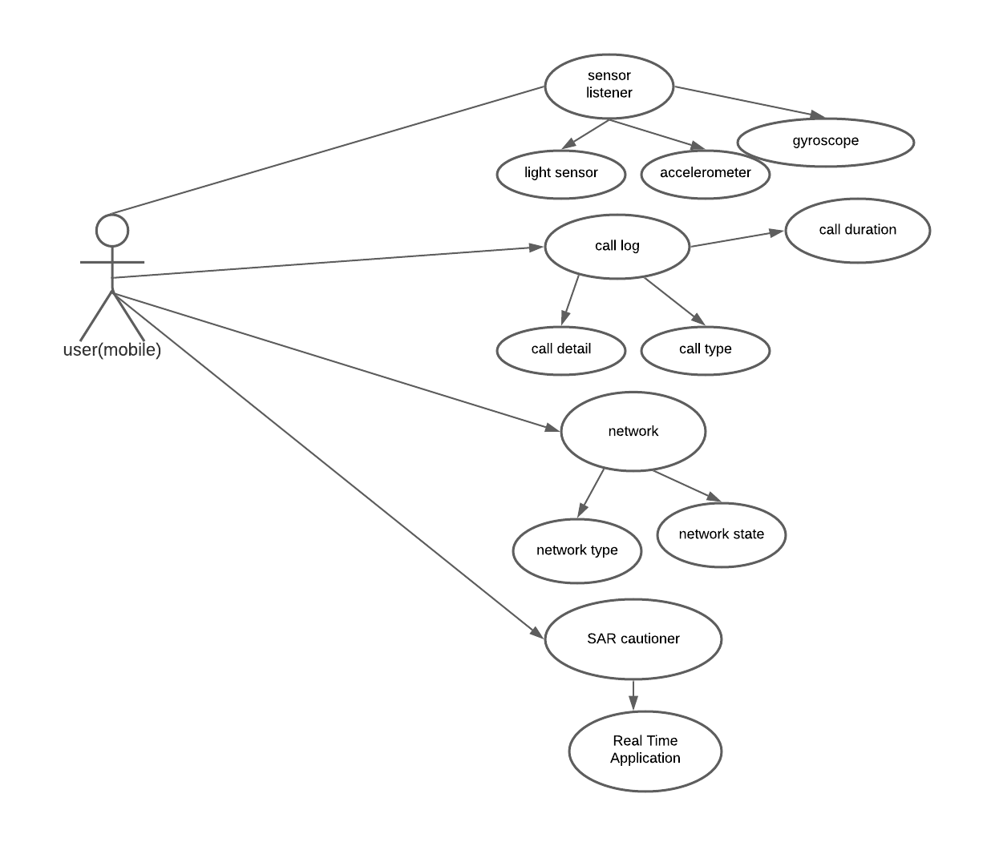

Fig 4.4 Use case diagram

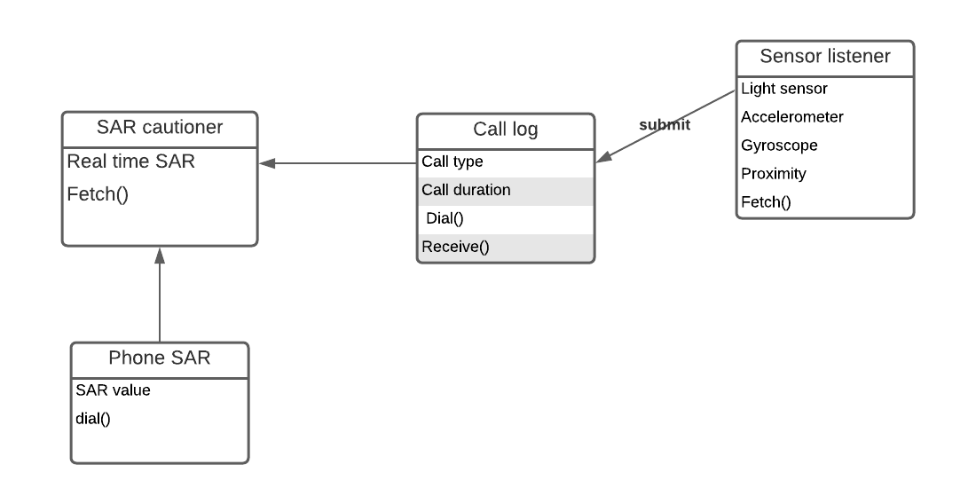

Fig 4.5 Class diagram

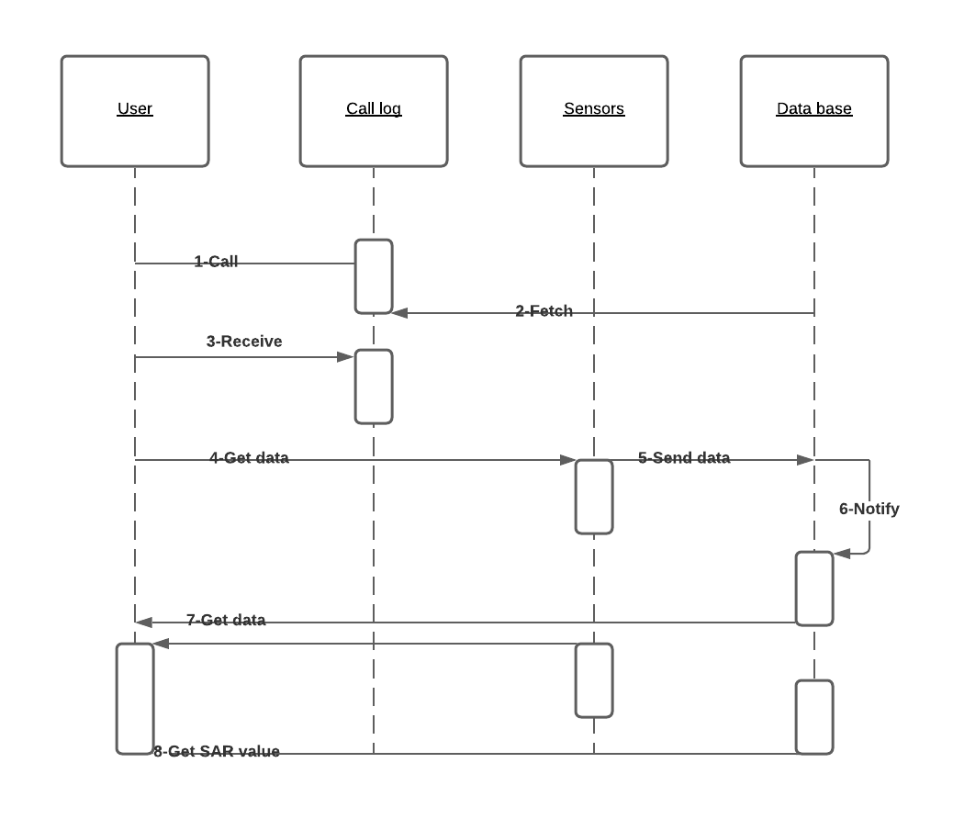

Fig 4.6 Sequence diagram

### CHAPTER 5 ARCHITECTURE

#### SYSTEMARCHITECTURE

System architecture is the conceptual model that defines the structure, behavior, and more views of a system. An architecture description is a formal description and representation of a system, organized in a way that supports reasoning about the structures and behaviors of thesystem.

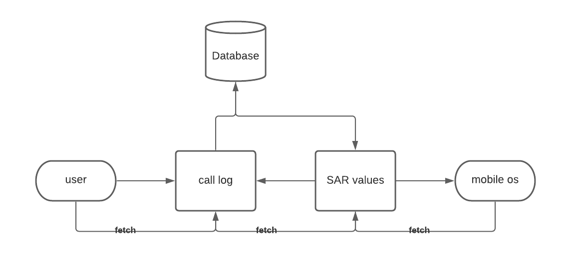

Fig 5.1 System Architecture

#### SYSTEMMODULE

#### MODULES EXPLAINATION:

The Specific Absorption Rate modules functions namely:

* + 1. User Call Log

The SAR application fetches the call duration and call type through which it calculates

the SAR value and checks whether it is in mentioned limits. With the help of the user call

duration we calculate the Actual amount of radiation that has passed through the human

brain. This module is one among the main module that is directly connected to the

sensors and DB where each call duration and its network state and charging status is

recorded.

* + 1. SAR Monitoring DB

The Specific Absorption Rate stores the value of each time the SAR recorded in the Data

Base. It fetches the information from Sensor listeners and also the call duration log. It

processes the SAR values monitored for one whole week and displays the bar chart for the

above recorded values.There is also an option to check your phone SAR using the code

mentioned in the option. It also displays the circle with percentage of SAR passed.

#### MODULES EXPLAINATION:

#### PROGRAM LANGUAGE DESIGN

Build

buildscript {

repositories {

google()

jcenter()

}

dependencies {

classpath 'com.android.tools.build:gradle:3.5.3'

// NOTE: Do not place your application dependencies here; they belong

// in the individual module build.gradle files

}

}

allprojects {

repositories {

google()

jcenter()

}

}

task clean(type: Delete) {

delete rootProject.buildDir

}

**CHAPTER 6 TESTING**

#### SYSTEM TESTING

The testing approach document is designed for Information and Technology Services’ upgrades to PeopleSoft. The document contains an overview of the testing activities to be performed when an upgrade or enhancement is made, or a module is added to an existing application. The emphasis is on testing critical business processes, while minimizing the time necessary for testing while also mitigating risks. It’s important to note that reducing the amount of testing done in an upgrade increases the potential for problems after go-live. Management will need to determine how much risk is acceptable on an upgrade by upgrade basis.

System testing is simply testing the system as a whole; it gets all the integrated modules of the various components from the integration testing phase and combines all the different parts into a system which is then tested. Testing is then done on the system as all the parts are now integrated into one system the testing phase will now have to be done on the system to check and remove any errors or bugs. In the system testing process the system will be checked not only for errors but also to see if the system does what was intended, the system functionality and if it is what the end user expected.

There are various tests that need to be conducted again in the system testing which include:



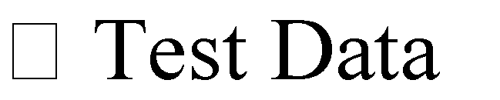

If the integration stage was done accurately then most of the test plan and test cases would already have been done and simple testing would only have to be done in order to ensure there are no bugs because this will be the final product. As in the integration stage, the above steps would need to be re-done as now we have

integrated all modules into one system, so we have to check if this runs OK and that no errors are produced because all the modules are in one system.

#### Unit Testing

In computer programming, unit testing is a software testing method by which individual units of source code, sets of one or more computer program modules together with associated control data, usage procedures, and operating procedures are tested to determine if they are fit for use. In object-oriented programming, a unit is often an entire interface, such as a class, but could be an individual method. Unit tests are short code fragments created by programmers or occasionally by white box testers during the development process. Ideally, each test case is independent from the others. Substitutes such as method stubs, mock objects, fakes, and test harnesses can be used to assist testing a module in isolation. Unit tests are typically written and run by software developers to ensure that code meets its design and behaves as intended.

#### TESTCASES

|  |  |  |  |  |  |  |  |
| --- | --- | --- | --- | --- | --- | --- | --- |
| Test Case Id | Test Cases | Priority | Input TesData | Test Case Description | Expected Results | Actual Results | Pass/Fai l |
| TU0 1 | Check phone SAR | A | Dial \*#07# | Check user  Mobile SAR | Get phone SAR | Phone SAR in Mobile  Phones | Pass |
| TU0 2 | Dial  Phone  Call | A | Call Duration | Takes the Call duration | Check SAR within limits or  not | Actual SAR  Value | Pass |
| TU0 3 | Receive  Phone call | A | Call Duration | Takes the Call duration | Check SAR within limits or  not | Check SAR within limits or  not | Pass |

Table 6.1 Test Cases for User Module

## CHAPTER 7

**CONCLUSION AND FUTURE ENHANCEMENT**

#### CONCLUSION

This guidance system provides an easier platform for mobile users to control their usage of mobile phones during calls. Since it creates an awareness of the radiation passed through the human body and brain. This application also cautions the user not to use mobile phones in charging mode.

#### FUTUREENHANCEMENT

In the further enhancement we are planning to add features such as detailed report with maximum and minimum SAR values for one month and also increase the efficiency of the algorithm in calculating the SAR values.

**APPENDICES**

**A 1. SAMPLE SCREENS**

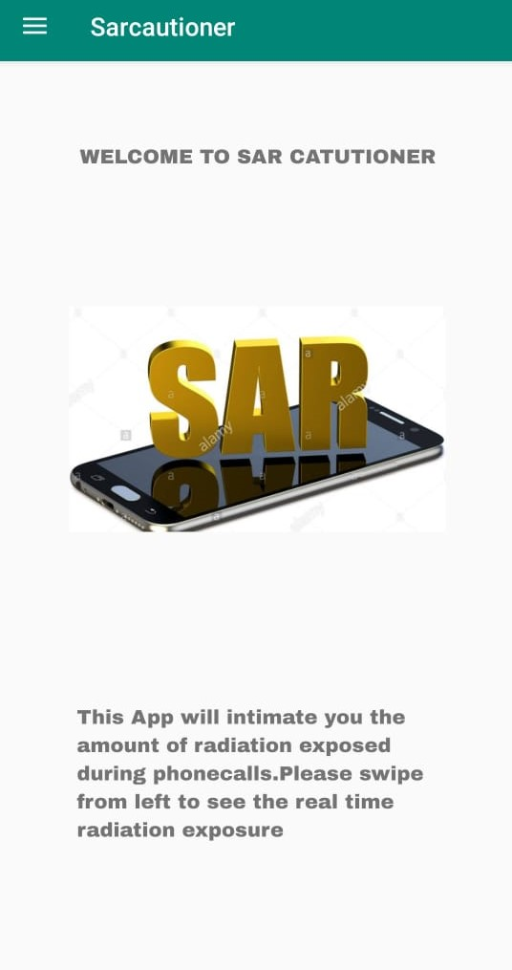 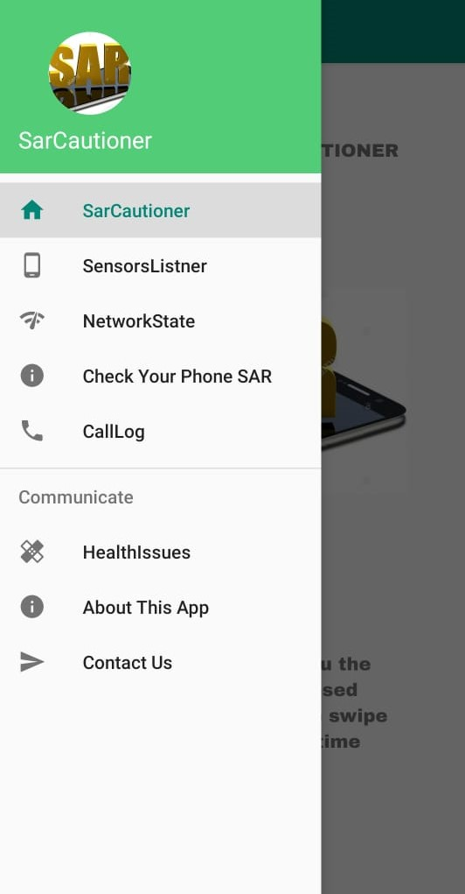

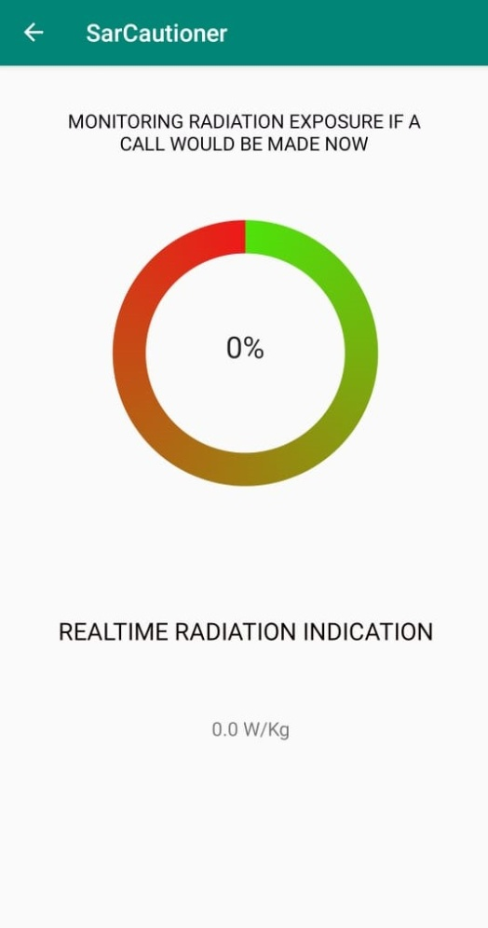 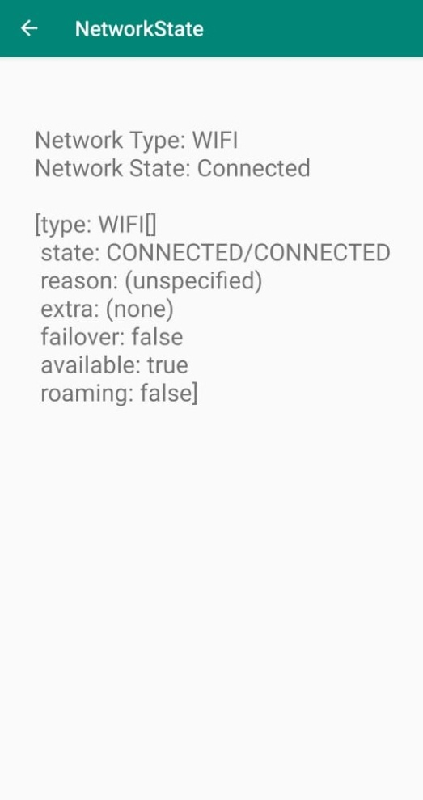

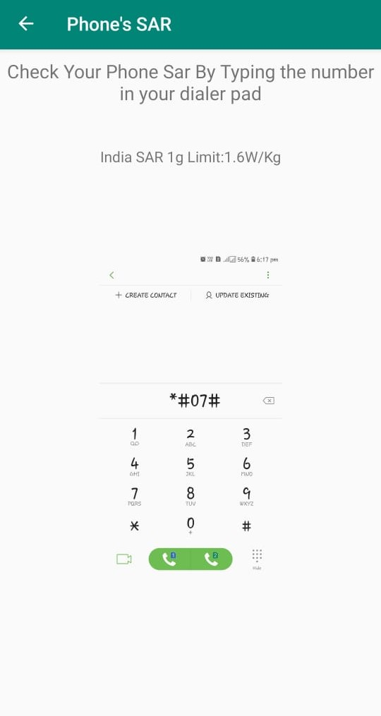 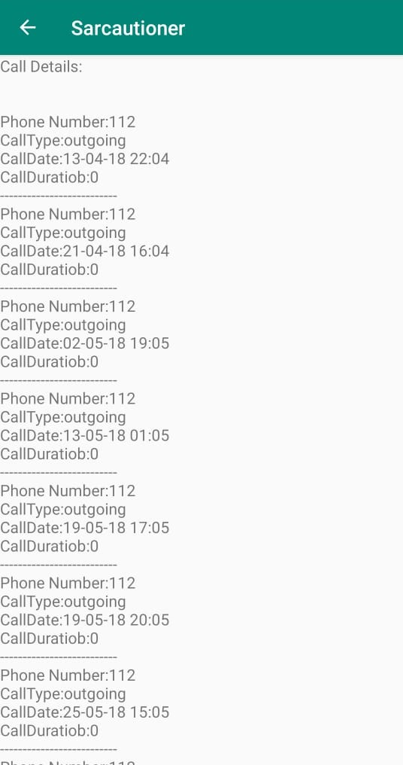

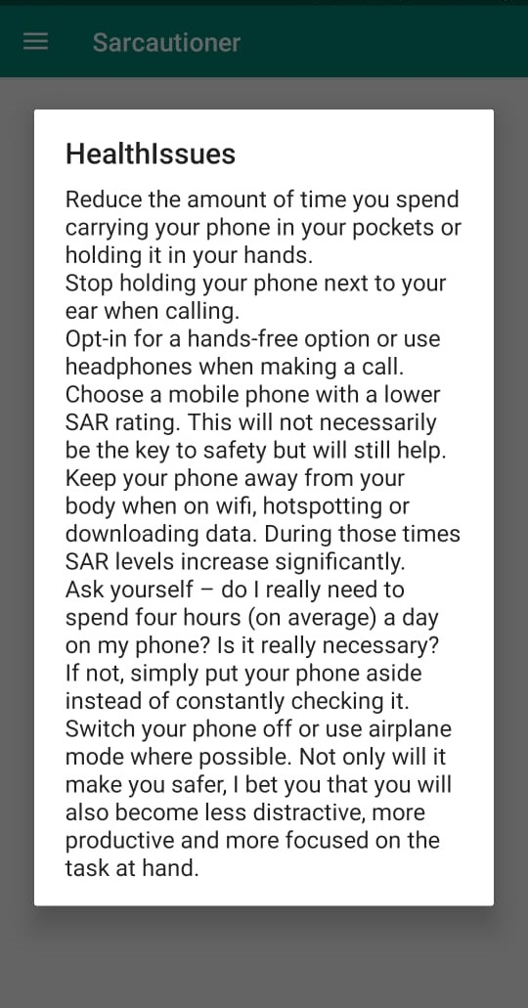 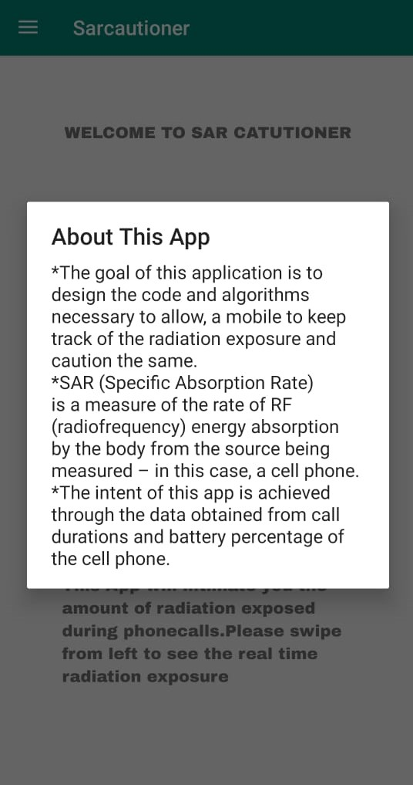

### A2. SAMPLE CODE

**BatteryReceiver.java**

package com.example.sarcautioner;

import android.content.BroadcastReceiver;

import android.content.Context;

import android.content.Intent;

import android.os.BatteryManager;

import android.widget.TextView;

public class BatteryReceiver extends BroadcastReceiver {

@Override

public void onReceive(Context context, Intent intent) {

TextView statusLabel = ((SensorListner)context).findViewById(R.id.statusLabel);

TextView percentageLabel = ((SensorListner)context).findViewById(R.id.percentageLabel);

String action = intent.getAction();

if (action != null && action.equals(Intent.ACTION\_BATTERY\_CHANGED)) {

// Status

int status = intent.getIntExtra(BatteryManager.EXTRA\_STATUS, -1);

String message = "";

switch (status) {

case BatteryManager.BATTERY\_STATUS\_FULL:

message = "Full";

break;

case BatteryManager.BATTERY\_STATUS\_CHARGING:

message = "Charging";

break;

case BatteryManager.BATTERY\_STATUS\_DISCHARGING:

message = "Discharging";

break;

case BatteryManager.BATTERY\_STATUS\_NOT\_CHARGING:

message = "Not charging";

break;

case BatteryManager.BATTERY\_STATUS\_UNKNOWN:

message = "Unknown";

break;

}

statusLabel.setText(message);

// Percentage

int level = intent.getIntExtra(BatteryManager.EXTRA\_LEVEL, -1);

int scale = intent.getIntExtra(BatteryManager.EXTRA\_SCALE, -1);

int percentage = level \* 100 / scale;

percentageLabel.setText(percentage + "%");

}

}

}

**CallLog.java**

package com.example.sarcautioner;

import androidx.annotation.NonNull;

import androidx.appcompat.app.AppCompatActivity;

import androidx.core.app.ActivityCompat;

import androidx.core.content.ContextCompat;

import android.Manifest;

import android.content.pm.PackageManager;

import android.database.Cursor;

import android.os.Bundle;

import android.widget.TextView;

import android.widget.Toast;

import java.sql.Date;

import java.text.SimpleDateFormat;

public class CallLog extends AppCompatActivity {

@Override

protected void onCreate(Bundle savedInstanceState) {

super.onCreate(savedInstanceState);

setContentView(R.layout.activity\_call\_log);

if (ContextCompat.checkSelfPermission(CallLog.this,

Manifest.permission.READ\_CALL\_LOG) != PackageManager.PERMISSION\_GRANTED) {

if (ActivityCompat.shouldShowRequestPermissionRationale(CallLog.this,

Manifest.permission.READ\_CALL\_LOG)) {

ActivityCompat.requestPermissions(CallLog.this,

new String[]{Manifest.permission.READ\_CALL\_LOG}, 1);

} else {

ActivityCompat.requestPermissions(CallLog.this,

new String[]{Manifest.permission.READ\_CALL\_LOG}, 1);

}

} else {

//do stuff

TextView textView = (TextView) findViewById(R.id.textView);

textView.setText(getCallDetails());

}

}

@Override

public void onRequestPermissionsResult(int requestCode, @NonNull String[] permissions, int[] grantResults) {

switch (requestCode) {

case 1: {

if (grantResults.length > 0 && grantResults[0] == PackageManager.PERMISSION\_GRANTED) {

if (ContextCompat.checkSelfPermission(CallLog.this,

Manifest.permission.READ\_CALL\_LOG) == PackageManager.PERMISSION\_GRANTED) {

Toast.makeText(this, "Permission Granted", Toast.LENGTH\_SHORT).show();

//do stuff

TextView textView = (TextView) findViewById(R.id.textView);

textView.setText(getCallDetails());

}

} else {

Toast.makeText(this, "Denied", Toast.LENGTH\_SHORT).show();

}

}

return;

}

}

public String getCallDetails() {

StringBuffer sb = new StringBuffer();

Cursor managerCursor = getContentResolver().query(android.provider.CallLog.Calls.CONTENT\_URI, null, null, null, null);

int number = managerCursor.getColumnIndex(android.provider.CallLog.Calls.NUMBER);

int type = managerCursor.getColumnIndex(android.provider.CallLog.Calls.TYPE);

int date = managerCursor.getColumnIndex(android.provider.CallLog.Calls.DATE);

int duration = managerCursor.getColumnIndex(android.provider.CallLog.Calls.DURATION);

sb.append("Call Details:\n\n");

while (managerCursor.moveToNext()) {

String phnumber = managerCursor.getString(number);

String callType = managerCursor.getString(type);

String callDate = managerCursor.getString(date);

Date callDayTime = new Date(Long.valueOf(callDate));

SimpleDateFormat formatter = new SimpleDateFormat("dd-MM-yy HH:MM");

String dateString = formatter.format(callDayTime);

String callDuration = managerCursor.getString(duration);

String dir = null;

int dircode = Integer.parseInt(callType);

switch (dircode) {

case android.provider.CallLog.Calls.OUTGOING\_TYPE:

dir = "outgoing";

break;

case android.provider.CallLog.Calls.INCOMING\_TYPE:

dir = "incoming";

break;

case android.provider.CallLog.Calls.MISSED\_TYPE:

dir = "missed";

break;

}

sb.append("\nPhone Number:" + phnumber +

"\nCall Type:" + dir +

"\nCall Date:" + dateString +

"\nCall Duration:" + callDuration);

sb.append("\n--------------------------");

}

managerCursor.close();

return sb.toString();

}

}

**CheckSar.java**

package com.example.sarcautioner;

import androidx.annotation.NonNull;

import androidx.appcompat.app.AppCompatActivity;

import androidx.core.app.ActivityCompat;

import androidx.core.content.ContextCompat;

import android.Manifest;

import android.content.Intent;

import android.content.pm.PackageManager;

import android.net.Uri;

import android.os.Bundle;

import android.view.View;

import android.widget.ImageView;

import android.widget.Toast;

public class CheckSar extends AppCompatActivity {

private static final int REQUEST\_CALL =1;

@Override

protected void onCreate(Bundle savedInstanceState) {

super.onCreate(savedInstanceState);

setContentView(R.layout.activity\_check\_sar);

getSupportActionBar().setTitle("Phone's SAR");

}

}

**MainActivity.java**

package com.example.sarcautioner;

import androidx.annotation.NonNull;

import androidx.appcompat.app.ActionBarDrawerToggle;

import androidx.appcompat.app.AppCompatActivity;

import androidx.appcompat.widget.Toolbar;

import androidx.core.view.GravityCompat;

import androidx.drawerlayout.widget.DrawerLayout;

import android.app.AlertDialog;

import android.content.Intent;

import android.os.Bundle;

import android.view.MenuItem;

import com.google.android.material.navigation.NavigationView;

public class MainActivity extends AppCompatActivity implements NavigationView.OnNavigationItemSelectedListener {

//creating variable for drawerlayout

private DrawerLayout drawer;

@Override

protected void onCreate(Bundle savedInstanceState) {

super.onCreate(savedInstanceState);

setContentView(R.layout.activity\_main);

Toolbar toolbar = findViewById(R.id.toolbar);

setSupportActionBar(toolbar);

drawer = findViewById(R.id.drawer\_layout);

NavigationView navigationView = findViewById(R.id.nav\_view);

navigationView.setNavigationItemSelectedListener(this);

ActionBarDrawerToggle toggle = new ActionBarDrawerToggle(this, drawer, toolbar,

R.string.navigation\_drawer\_open, R.string.navigation\_drawer\_close);

drawer.addDrawerListener(toggle);

toggle.syncState();

if(savedInstanceState==null){

getSupportFragmentManager().beginTransaction().replace(R.id.fragment\_container,

new MessageFragment()).commit();

navigationView.setCheckedItem(R.id.nav\_sar);

}}

public void setActionBarTitle(String title){

getSupportActionBar().setTitle(title);

}

@Override

public boolean onNavigationItemSelected(@NonNull MenuItem item) {

switch (item.getItemId()){

case R.id.nav\_sar:

Intent i = new Intent(MainActivity.this,SarCautionerActivity.class);

startActivity(i);

break;

case R.id.nav\_sensor:

Intent j = new Intent(MainActivity.this,SensorListner.class);

startActivity(j);

break;

case R.id.nav\_network:

Intent k = new Intent(MainActivity.this,NetworkStateActivity.class);

startActivity(k);

break;

case R.id.nav\_call:

Intent l = new Intent(MainActivity.this,CheckSar.class);

startActivity(l);

break;

case R.id.nav\_calllog:

Intent m = new Intent(MainActivity.this,CallLog.class);

startActivity(m);

break;

case R.id.nav\_share:

showMessage("About This App","\*The goal of this application is to design the code and algorithms necessary to allow, a mobile to keep track of the radiation exposure and caution the same.\n" +

"\*SAR (Specific Absorption Rate) is a measure of the rate of RF (radiofrequency) energy absorption by the body from the source being measured – in this case, a cell phone.\n" +

"\*The intent of this app is achieved through the data obtained from call durations and battery percentage of the cell phone.");

break;

case R.id.nav\_send:

showMessage("Contact Us","We highly recommend you to help us improve.Give us your FeedBack to this Mail Address\n"+

"Z.John Joseph\n"+

"E-Mail=zjohnjoseph@gmail.com\n"+

"D.Hariharan\n"+

"E-Mail=haran3075@gmail.com");

break;

case R.id.nav\_healthissue:

showMessage("HealthIssues","Reduce the amount of time you spend carrying your phone in your pockets or holding it in your hands.\n" +

"Stop holding your phone next to your ear when calling.\n" +

"Opt-in for a hands-free option or use headphones when making a call.\n" +

"Choose a mobile phone with a lower SAR rating. This will not necessarily be the key to safety but will still help.\n" +

"Keep your phone away from your body when on wifi, hotspotting or downloading data. During those times SAR levels increase significantly.\n" +

"Ask yourself – do I really need to spend four hours (on average) a day on my phone? Is it really necessary? If not, simply put your phone aside instead of constantly checking it.\n" +

"Switch your phone off or use airplane mode where possible. Not only will it make you safer, I bet you that you will also become less distractive, more productive and more focused on the task at hand.");

}

drawer.closeDrawer(GravityCompat.START);

return true;

}

@Override

public void onBackPressed() {

if (drawer.isDrawerOpen(GravityCompat.START)) {

drawer.closeDrawer(GravityCompat.START);

} else {

super.onBackPressed();

}

}

public void showMessage(String title,String message)

{

AlertDialog.Builder builder=new AlertDialog.Builder(this);

builder.setCancelable(true);

builder.setTitle(title);

builder.setMessage(message);

builder.show();

}

}

**MessageFragment.java**

package com.example.sarcautioner;

import android.os.Bundle;

import android.view.LayoutInflater;

import android.view.View;

import android.view.ViewGroup;

import androidx.annotation.NonNull;

import androidx.annotation.Nullable;

import androidx.fragment.app.Fragment;

public class MessageFragment extends Fragment {

@Nullable

@Override

public View onCreateView(@NonNull LayoutInflater inflater, @Nullable ViewGroup container, @Nullable Bundle savedInstanceState) {

return inflater.inflate(R.layout.fragment\_message,container,false);

}

}

**NetworkStateActivity.java**

package com.example.sarcautioner;

import androidx.appcompat.app.AppCompatActivity;

import android.content.BroadcastReceiver;

import android.content.Context;

import android.content.Intent;

import android.content.IntentFilter;

import android.net.ConnectivityManager;

import android.net.NetworkInfo;

import android.os.Bundle;

import android.util.Log;

import android.widget.TextView;

public class NetworkStateActivity extends AppCompatActivity {

private ConnectivityReceiver receiver = null;

private TextView txtNetworkInfo = null;

@Override

protected void onCreate(Bundle savedInstanceState) {

super.onCreate(savedInstanceState);

setContentView(R.layout.activity\_network\_state);

getSupportActionBar().setTitle("NetworkState");

txtNetworkInfo = (TextView) findViewById(R.id.tvinfo);

receiver = new ConnectivityReceiver();

registerReceiver(receiver, new IntentFilter(ConnectivityManager.CONNECTIVITY\_ACTION));

}

@Override

protected void onDestroy() {

unregisterReceiver(receiver);

super.onDestroy();

}

private String getNetworkStateString(NetworkInfo.State state) {

String stateString = "Unknown";

switch (state) {

case CONNECTED:

stateString = "Connected";

break;

case CONNECTING:

stateString = "Connecting";

break;

case DISCONNECTED:

stateString = "Disconnected";

break;

case DISCONNECTING:

stateString = "Disconnecting";

break;

case SUSPENDED:

stateString = "Suspended";

break;

default:

stateString = "Unknown";

break;

}

return stateString;

}

private class ConnectivityReceiver extends BroadcastReceiver {

@Override

public void onReceive(Context context, Intent intent) {

// In this example i using " EXTRA\_NETWORK\_INFO " The NetworkInfo object containing all information about the current state of this network type

NetworkInfo info = intent

.getParcelableExtra(ConnectivityManager.EXTRA\_NETWORK\_INFO);

if (null != info) {

String state = getNetworkStateString(info.getState());

String stateString = info.toString().replace(',', '\n');

String infoString = String.format(

"Network Type: %s\nNetwork State: %s\n\n%s",

info.getTypeName(), state, stateString);

Log.i("ConnTest", info.getTypeName());

Log.i("ConnTest", state);

Log.i("ConnTest", info.toString());

txtNetworkInfo.setText(infoString);

}

}

}

}

**SarCautionerActivity.java**

package com.example.sarcautioner;

import androidx.annotation.NonNull;

import androidx.appcompat.app.AppCompatActivity;

import androidx.core.content.ContextCompat;

import android.Manifest;

import android.content.pm.PackageManager;

import android.database.Cursor;

import android.os.Build;

import android.os.Bundle;

import android.os.Handler;

import android.widget.ProgressBar;

import android.widget.TextView;

import android.widget.Toast;

public class SarCautionerActivity extends AppCompatActivity {

public TextView txtProgress;

public ProgressBar progressBar;

public TextView sarval;

public TextView manufacturer;

Float brandsarval;

String brand = Build.BRAND;

public int pStatus = 0;

public Handler handler = new Handler();

@Override

protected void onCreate(Bundle savedInstanceState) {

super.onCreate(savedInstanceState);

setContentView(R.layout.activity\_sar\_cautioner);

getSupportActionBar().setTitle("SarCautioner");

// Initialize all view variables.

sarval=(TextView)findViewById(R.id.val);

txtProgress = (TextView) findViewById(R.id.txtProgress);

manufacturer=(TextView)findViewById(R.id.brand);

progressBar = (ProgressBar) findViewById(R.id.progressBar);

// Get an instance of the sensor manager.

if(brand.equals("samsung")){

brandsarval=1.1f;

}else {

brandsarval=1.9f;

}

String seconds = getCallDetails();

Integer sec=Integer.parseInt(seconds);

Float minutes=(float)sec/60;

Double sar=(minutes\*0.032)/6;

String sarvalue=String.valueOf(sar);

Double percent=(sar/brandsarval)\*100;

Long per=Math.round(percent);

String s=String.valueOf(per);

Integer i=Integer.parseInt(s);

progressBar.setProgress(i);

txtProgress.setText(i+"%");

sarval.setText(sarvalue+" W/Kg");

manufacturer.setText(brand);

}

@Override

public void onRequestPermissionsResult(int requestCode, @NonNull String[] permissions, int[] grantResults) {

switch (requestCode) {

case 1: {

if (grantResults.length > 0 && grantResults[0] == PackageManager.PERMISSION\_GRANTED) {

if (ContextCompat.checkSelfPermission(SarCautionerActivity.this,

Manifest.permission.READ\_CALL\_LOG) == PackageManager.PERMISSION\_GRANTED) {

Toast.makeText(this, "Permission Granted", Toast.LENGTH\_SHORT).show();

}

} else {

Toast.makeText(this, "Denied", Toast.LENGTH\_SHORT).show();

}

}

return;

}

}

public String getCallDetails() {

StringBuffer sb = new StringBuffer();

Cursor managerCursor = getContentResolver().query(android.provider.CallLog.Calls.CONTENT\_URI, null, null, null, null);

int duration = managerCursor.getColumnIndex(android.provider.CallLog.Calls.DURATION);

while (managerCursor.moveToNext()) {

String callDuration = managerCursor.getString(duration);

sb.append(callDuration);

break;

}

managerCursor.close();

return sb.toString();

}

}

**SensorListner.java**

package com.example.sarcautioner;

import androidx.appcompat.app.AppCompatActivity;

import android.content.Context;

import android.content.Intent;

import android.content.IntentFilter;

import android.hardware.Sensor;

import android.hardware.SensorEvent;

import android.hardware.SensorEventListener;

import android.hardware.SensorManager;

import android.os.Bundle;

import android.widget.TextView;

import android.widget.Toast;

import java.lang.reflect.Method;

import java.util.List;

public class SensorListner extends AppCompatActivity implements SensorEventListener {

private BatteryReceiver mBatteryReceiver = new BatteryReceiver();

private IntentFilter mIntentFilter = new IntentFilter(Intent.ACTION\_BATTERY\_CHANGED);

private SensorManager mSensorManager;

private Sensor mSensorProximity;

private Sensor mSensorLight;

private Sensor mSensorAccelerometer;

private Sensor mSensorGyroscope;

public TextView mTextSensorLight;

public TextView mTextSensorProximity;

public TextView mTextSensorAccelerometer;

public TextView mTextSensorGyroscope;

@Override

protected void onCreate(Bundle savedInstanceState) {

super.onCreate(savedInstanceState);

setContentView(R.layout.activity\_sensor\_listner);

getSupportActionBar().setTitle("SensorListner");

mTextSensorLight = (TextView) findViewById(R.id.label\_light);

mTextSensorProximity = (TextView) findViewById(R.id.label\_proximity);

mTextSensorAccelerometer = (TextView) findViewById(R.id.label\_accelerometer);

mTextSensorGyroscope = (TextView) findViewById(R.id.label\_gyroscope);

mSensorManager = (SensorManager) getSystemService(Context.SENSOR\_SERVICE);

List<Sensor> SensorList = mSensorManager.getSensorList(Sensor.TYPE\_ALL);

StringBuilder sensorText = new StringBuilder();

for(Sensor currentsensor: SensorList){

sensorText.append(currentsensor.getName()).append(System.getProperty("line.separator"));

}

TextView sensorTextView = (TextView) findViewById(R.id.sensor\_list);

sensorTextView.setText(sensorText);

mSensorProximity = mSensorManager.getDefaultSensor(Sensor.TYPE\_PROXIMITY);

mSensorLight = mSensorManager.getDefaultSensor(Sensor.TYPE\_LIGHT);

mSensorAccelerometer = mSensorManager.getDefaultSensor(Sensor.TYPE\_ACCELEROMETER);

mSensorGyroscope = mSensorManager.getDefaultSensor(Sensor.TYPE\_GYROSCOPE);

// Get the error message from string resources.

String sensor\_error = getResources().getString(R.string.error\_no\_sensor);

if (mSensorLight == null) { mTextSensorLight.setText(sensor\_error); }

if (mSensorProximity == null) { mTextSensorProximity.setText(sensor\_error); }

if (mSensorAccelerometer == null) { mTextSensorAccelerometer.setText(sensor\_error); }

if (mSensorGyroscope == null) { mTextSensorGyroscope.setText(sensor\_error); }

}

@Override

protected void onStart() {

super.onStart();

// Listeners for the sensors are registered in this callback and

// can be unregistered in onPause().

//

// Check to ensure sensors are available before registering listeners.

// Both listeners are registered with a "normal" amount of delay

// (SENSOR\_DELAY\_NORMAL)

if (mSensorProximity != null) {

mSensorManager.registerListener(this, mSensorProximity,

SensorManager.SENSOR\_DELAY\_NORMAL);

}

if (mSensorLight != null) {

mSensorManager.registerListener(this, mSensorLight,

SensorManager.SENSOR\_DELAY\_NORMAL);

}

if (mSensorAccelerometer != null) {

mSensorManager.registerListener(this, mSensorAccelerometer,

SensorManager.SENSOR\_DELAY\_NORMAL);

}

if (mSensorGyroscope != null) {

mSensorManager.registerListener(this, mSensorGyroscope,

SensorManager.SENSOR\_DELAY\_NORMAL);

}

}

@Override

protected void onStop() {

super.onStop();

// Unregister all sensor listeners in this callback so they don't

// continue to use resources when the app is paused.

mSensorManager.unregisterListener(this);

}

@Override

public void onSensorChanged(SensorEvent sensorEvent) {

//String light;

// The sensor type (as defined in the Sensor class).

int sensorType = sensorEvent.sensor.getType();

// The new data value of the sensor. Both the light and proximity

// sensors report one value at a time, which is always the first

// element in the values array.

float currentValue = sensorEvent.values[0];

switch (sensorType) {

// Event came from the light sensor.

case Sensor.TYPE\_LIGHT:

// Set the light sensor text view to the light sensor string

// from the resources, with the placeholder filled in.

mTextSensorLight.setText(getResources().getString(

R.string.label\_light, currentValue));

break;

case Sensor.TYPE\_PROXIMITY:

// Set the proximity sensor text view to the proximmity sensor

// string from the resources, with the placeholder filled in.

mTextSensorProximity.setText(getResources().getString(

R.string.label\_proximity, currentValue));

break;

case Sensor.TYPE\_ACCELEROMETER:

// Set the accelerometer sensor text view to the accelerometer sensor

// string from the resources, with the placeholder filled in.

mTextSensorAccelerometer.setText(getResources().getString(

R.string.label\_accelerometer, currentValue));

break;

case Sensor.TYPE\_GYROSCOPE:

// Set the gyroscope sensor text view to the gyroscope sensor

// string from the resources, with the placeholder filled in.

mTextSensorGyroscope.setText(getResources().getString(

R.string.label\_gyroscope, currentValue));

break;

default:

// do nothing

}

}

/\*\*

\* Abstract method in SensorEventListener. It must be implemented, but is

\* unused in this app.

\*/

@Override

public void onAccuracyChanged(Sensor sensor, int i) {

}

@Override

protected void onResume() {

super.onResume();

registerReceiver(mBatteryReceiver, mIntentFilter);

}

@Override

protected void onPause() {

unregisterReceiver(mBatteryReceiver);

super.onPause();

}

}

**Package**

/\* AUTO-GENERATED FILE. DO NOT MODIFY.

\*

\* This class was automatically generated by the

\* gradle plugin from the resource data it found. It

\* should not be modified by hand.

\*/

package androidx.activity;

public final class R {

private R() {}

public static final class attr {

private attr() {}

public static final int alpha = 0x7f040028;

public static final int font = 0x7f040123;

public static final int fontProviderAuthority = 0x7f040125;

public static final int fontProviderCerts = 0x7f040126;

public static final int fontProviderFetchStrategy = 0x7f040127;

public static final int fontProviderFetchTimeout = 0x7f040128;

public static final int fontProviderPackage = 0x7f040129;

public static final int fontProviderQuery = 0x7f04012a;

public static final int fontStyle = 0x7f04012b;

public static final int fontVariationSettings = 0x7f04012c;

public static final int fontWeight = 0x7f04012d;

public static final int ttcIndex = 0x7f0402af;

}

public static final class color {

private color() {}

public static final int notification\_action\_color\_filter = 0x7f0600ac;

public static final int notification\_icon\_bg\_color = 0x7f0600ad;

public static final int ripple\_material\_light = 0x7f0600b7;

public static final int secondary\_text\_default\_material\_light = 0x7f0600b9;

}

public static final class dimen {

private dimen() {}

public static final int compat\_button\_inset\_horizontal\_material = 0x7f070053;

public static final int compat\_button\_inset\_vertical\_material = 0x7f070054;

public static final int compat\_button\_padding\_horizontal\_material = 0x7f070055;

public static final int compat\_button\_padding\_vertical\_material = 0x7f070056;

public static final int compat\_control\_corner\_material = 0x7f070057;

public static final int compat\_notification\_large\_icon\_max\_height = 0x7f070058;

public static final int compat\_notification\_large\_icon\_max\_width = 0x7f070059;

public static final int notification\_action\_icon\_size = 0x7f07013f;

public static final int notification\_action\_text\_size = 0x7f070140;

public static final int notification\_big\_circle\_margin = 0x7f070141;

public static final int notification\_content\_margin\_start = 0x7f070142;

public static final int notification\_large\_icon\_height = 0x7f070143;

public static final int notification\_large\_icon\_width = 0x7f070144;

public static final int notification\_main\_column\_padding\_top = 0x7f070145;

public static final int notification\_media\_narrow\_margin = 0x7f070146;

public static final int notification\_right\_icon\_size = 0x7f070147;

public static final int notification\_right\_side\_padding\_top = 0x7f070148;

public static final int notification\_small\_icon\_background\_padding = 0x7f070149;

public static final int notification\_small\_icon\_size\_as\_large = 0x7f07014a;

public static final int notification\_subtext\_size = 0x7f07014b;

public static final int notification\_top\_pad = 0x7f07014c;

public static final int notification\_top\_pad\_large\_text = 0x7f07014d;

}

public static final class drawable {

private drawable() {}

public static final int notification\_action\_background = 0x7f08008c;

public static final int notification\_bg = 0x7f08008d;

public static final int notification\_bg\_low = 0x7f08008e;

public static final int notification\_bg\_low\_normal = 0x7f08008f;

public static final int notification\_bg\_low\_pressed = 0x7f080090;

public static final int notification\_bg\_normal = 0x7f080091;

public static final int notification\_bg\_normal\_pressed = 0x7f080092;

public static final int notification\_icon\_background = 0x7f080093;

public static final int notification\_template\_icon\_bg = 0x7f080094;

public static final int notification\_template\_icon\_low\_bg = 0x7f080095;

public static final int notification\_tile\_bg = 0x7f080096;

public static final int notify\_panel\_notification\_icon\_bg = 0x7f080097;

}

public static final class id {

private id() {}

public static final int accessibility\_action\_clickable\_span = 0x7f0a000a;

public static final int accessibility\_custom\_action\_0 = 0x7f0a000b;

public static final int accessibility\_custom\_action\_1 = 0x7f0a000c;

public static final int accessibility\_custom\_action\_10 = 0x7f0a000d;

public static final int accessibility\_custom\_action\_11 = 0x7f0a000e;

public static final int accessibility\_custom\_action\_12 = 0x7f0a000f;

public static final int accessibility\_custom\_action\_13 = 0x7f0a0010;

public static final int accessibility\_custom\_action\_14 = 0x7f0a0011;

public static final int accessibility\_custom\_action\_15 = 0x7f0a0012;

public static final int accessibility\_custom\_action\_16 = 0x7f0a0013;

public static final int accessibility\_custom\_action\_17 = 0x7f0a0014;

public static final int accessibility\_custom\_action\_18 = 0x7f0a0015;

public static final int accessibility\_custom\_action\_19 = 0x7f0a0016;

public static final int accessibility\_custom\_action\_2 = 0x7f0a0017;

public static final int accessibility\_custom\_action\_20 = 0x7f0a0018;

public static final int accessibility\_custom\_action\_21 = 0x7f0a0019;

public static final int accessibility\_custom\_action\_22 = 0x7f0a001a;

public static final int accessibility\_custom\_action\_23 = 0x7f0a001b;

public static final int accessibility\_custom\_action\_24 = 0x7f0a001c;

public static final int accessibility\_custom\_action\_25 = 0x7f0a001d;

public static final int accessibility\_custom\_action\_26 = 0x7f0a001e;

public static final int accessibility\_custom\_action\_27 = 0x7f0a001f;

public static final int accessibility\_custom\_action\_28 = 0x7f0a0020;

public static final int accessibility\_custom\_action\_29 = 0x7f0a0021;

public static final int accessibility\_custom\_action\_3 = 0x7f0a0022;

public static final int accessibility\_custom\_action\_30 = 0x7f0a0023;

public static final int accessibility\_custom\_action\_31 = 0x7f0a0024;

public static final int accessibility\_custom\_action\_4 = 0x7f0a0025;

public static final int accessibility\_custom\_action\_5 = 0x7f0a0026;

public static final int accessibility\_custom\_action\_6 = 0x7f0a0027;

public static final int accessibility\_custom\_action\_7 = 0x7f0a0028;

public static final int accessibility\_custom\_action\_8 = 0x7f0a0029;

public static final int accessibility\_custom\_action\_9 = 0x7f0a002a;

public static final int action\_container = 0x7f0a0032;

public static final int action\_divider = 0x7f0a0034;

public static final int action\_image = 0x7f0a0035;

public static final int action\_text = 0x7f0a003b;

public static final int actions = 0x7f0a003c;

public static final int async = 0x7f0a0042;

public static final int blocking = 0x7f0a0046;

public static final int chronometer = 0x7f0a0056;

public static final int dialog\_button = 0x7f0a006b;

public static final int forever = 0x7f0a0080;

public static final int icon = 0x7f0a008a;

public static final int icon\_group = 0x7f0a008b;

public static final int info = 0x7f0a0090;

public static final int italic = 0x7f0a0092;

public static final int line1 = 0x7f0a009b;

public static final int line3 = 0x7f0a009c;

public static final int normal = 0x7f0a00cc;

public static final int notification\_background = 0x7f0a00cd;

public static final int notification\_main\_column = 0x7f0a00ce;

public static final int notification\_main\_column\_container = 0x7f0a00cf;

public static final int right\_icon = 0x7f0a00e3;

public static final int right\_side = 0x7f0a00e4;

public static final int tag\_accessibility\_actions = 0x7f0a0117;

public static final int tag\_accessibility\_clickable\_spans = 0x7f0a0118;

public static final int tag\_accessibility\_heading = 0x7f0a0119;

public static final int tag\_accessibility\_pane\_title = 0x7f0a011a;

public static final int tag\_screen\_reader\_focusable = 0x7f0a011b;

public static final int tag\_transition\_group = 0x7f0a011c;

public static final int tag\_unhandled\_key\_event\_manager = 0x7f0a011d;

public static final int tag\_unhandled\_key\_listeners = 0x7f0a011e;

public static final int text = 0x7f0a0121;

public static final int text2 = 0x7f0a0122;

public static final int time = 0x7f0a0138;

public static final int title = 0x7f0a0139;

}

public static final class integer {

private integer() {}

public static final int status\_bar\_notification\_info\_maxnum = 0x7f0b0014;

}

public static final class layout {

private layout() {}

public static final int custom\_dialog = 0x7f0d0022;

public static final int notification\_action = 0x7f0d0050;

public static final int notification\_action\_tombstone = 0x7f0d0051;

public static final int notification\_template\_custom\_big = 0x7f0d0052;

public static final int notification\_template\_icon\_group = 0x7f0d0053;

public static final int notification\_template\_part\_chronometer = 0x7f0d0054;

public static final int notification\_template\_part\_time = 0x7f0d0055;

}

public static final class string {

private string() {}

public static final int status\_bar\_notification\_info\_overflow = 0x7f11005c;

}

public static final class style {

private style() {}

public static final int TextAppearance\_Compat\_Notification = 0x7f120159;

public static final int TextAppearance\_Compat\_Notification\_Info = 0x7f12015a;

public static final int TextAppearance\_Compat\_Notification\_Line2 = 0x7f12015b;

public static final int TextAppearance\_Compat\_Notification\_Time = 0x7f12015c;

public static final int TextAppearance\_Compat\_Notification\_Title = 0x7f12015d;

public static final int Widget\_Compat\_NotificationActionContainer = 0x7f12023f;

public static final int Widget\_Compat\_NotificationActionText = 0x7f120240;

}

public static final class styleable {

private styleable() {}

public static final int[] ColorStateListItem = { 0x10101a5, 0x101031f, 0x7f040028 };

public static final int ColorStateListItem\_android\_color = 0;

public static final int ColorStateListItem\_android\_alpha = 1;

public static final int ColorStateListItem\_alpha = 2;

public static final int[] FontFamily = { 0x7f040125, 0x7f040126, 0x7f040127, 0x7f040128, 0x7f040129, 0x7f04012a };

public static final int FontFamily\_fontProviderAuthority = 0;

public static final int FontFamily\_fontProviderCerts = 1;

public static final int FontFamily\_fontProviderFetchStrategy = 2;

public static final int FontFamily\_fontProviderFetchTimeout = 3;

public static final int FontFamily\_fontProviderPackage = 4;

public static final int FontFamily\_fontProviderQuery = 5;

public static final int[] FontFamilyFont = { 0x1010532, 0x1010533, 0x101053f, 0x101056f, 0x1010570, 0x7f040123, 0x7f04012b, 0x7f04012c, 0x7f04012d, 0x7f0402af };

public static final int FontFamilyFont\_android\_font = 0;

public static final int FontFamilyFont\_android\_fontWeight = 1;

public static final int FontFamilyFont\_android\_fontStyle = 2;

public static final int FontFamilyFont\_android\_ttcIndex = 3;

public static final int FontFamilyFont\_android\_fontVariationSettings = 4;

public static final int FontFamilyFont\_font = 5;

public static final int FontFamilyFont\_fontStyle = 6;

public static final int FontFamilyFont\_fontVariationSettings = 7;

public static final int FontFamilyFont\_fontWeight = 8;

public static final int FontFamilyFont\_ttcIndex = 9;

public static final int[] GradientColor = { 0x101019d, 0x101019e, 0x10101a1, 0x10101a2, 0x10101a3, 0x10101a4, 0x1010201, 0x101020b, 0x1010510, 0x1010511, 0x1010512, 0x1010513 };

public static final int GradientColor\_android\_startColor = 0;

public static final int GradientColor\_android\_endColor = 1;

public static final int GradientColor\_android\_type = 2;

public static final int GradientColor\_android\_centerX = 3;

public static final int GradientColor\_android\_centerY = 4;

public static final int GradientColor\_android\_gradientRadius = 5;

public static final int GradientColor\_android\_tileMode = 6;

public static final int GradientColor\_android\_centerColor = 7;

public static final int GradientColor\_android\_startX = 8;

public static final int GradientColor\_android\_startY = 9;

public static final int GradientColor\_android\_endX = 10;

public static final int GradientColor\_android\_endY = 11;

public static final int[] GradientColorItem = { 0x10101a5, 0x1010514 };

public static final int GradientColorItem\_android\_color = 0;

public static final int GradientColorItem\_android\_offset = 1;

}

}

**Build Configuration**

package com.example.sarcautioner.test;

public final class BuildConfig {

public static final boolean DEBUG = Boolean.parseBoolean("true");

public static final String APPLICATION\_ID = "com.example.sarcautioner.test";

public static final String BUILD\_TYPE = "debug";

public static final String FLAVOR = "";

public static final int VERSION\_CODE = 1;

public static final String VERSION\_NAME = "1.0";

}

**Instrumented Test**

package com.example.sarcautioner;

import android.content.Context;

import androidx.test.platform.app.InstrumentationRegistry;

import androidx.test.ext.junit.runners.AndroidJUnit4;

import org.junit.Test;

import org.junit.runner.RunWith;

import static org.junit.Assert.\*;

/\*\*

\* Instrumented test, which will execute on an Android device.

\*

\* @see <a href="http://d.android.com/tools/testing">Testing documentation</a>

\*/

@RunWith(AndroidJUnit4.class)

public class ExampleInstrumentedTest {

@Test

public void useAppContext() {

// Context of the app under test.

Context appContext = InstrumentationRegistry.getInstrumentation().getTargetContext();

assertEquals("com.example.sarcautioner", appContext.getPackageName());

}

}

**XML**

**AndroidMainfest.xml**

<?xml version="1.0" encoding="UTF-8"?>

[<manifest package="com.example.sarcautioner" xmlns:android="http://schemas.android.com/apk/res/android">](file:///C:\Users\vivek\AppData\Local\Temp\Rar$DIa46484.48632\AndroidManifest.xml)<uses-permission android:name="android.permission.ACCESS\_NETWORK\_STATE"/><uses-permission android:name="android.permission.CALL\_PHONE"/><uses-permission android:name="android.permission.READ\_CALL\_LOG"/>[<application android:theme="@style/AppTheme" android:supportsRtl="true" android:roundIcon="@drawable/welcomewallpaper" android:label="@string/app\_name" android:icon="@drawable/welcomewallpaper" android:allowBackup="true"><activity android:name=".CallLog">](file:///C:\Users\vivek\AppData\Local\Temp\Rar$DIa46484.48632\AndroidManifest.xml)<meta-data android:name="android.support.PARENT\_ACTIVITY" android:value=".MainActivity"/></activity>[<activity android:name=".CheckSar">](file:///C:\Users\vivek\AppData\Local\Temp\Rar$DIa46484.48632\AndroidManifest.xml)<meta-data android:name="android.support.PARENT\_ACTIVITY" android:value=".MainActivity"/></activity>[<activity android:name=".SensorListner">](file:///C:\Users\vivek\AppData\Local\Temp\Rar$DIa46484.48632\AndroidManifest.xml)<meta-data android:name="android.support.PARENT\_ACTIVITY" android:value=".MainActivity"/></activity>[<activity android:name=".SarCautionerActivity">](file:///C:\Users\vivek\AppData\Local\Temp\Rar$DIa46484.48632\AndroidManifest.xml)<meta-data android:name="android.support.PARENT\_ACTIVITY" android:value=".MainActivity"/></activity>[<activity android:name=".NetworkStateActivity">](file:///C:\Users\vivek\AppData\Local\Temp\Rar$DIa46484.48632\AndroidManifest.xml)<meta-data android:name="android.support.PARENT\_ACTIVITY" android:value=".MainActivity"/></activity>[<activity android:name=".MainActivity" android:theme="@style/AppTheme.NoActionBar"><intent-filter>](file:///C:\Users\vivek\AppData\Local\Temp\Rar$DIa46484.48632\AndroidManifest.xml)<action android:name="android.intent.action.MAIN"/><category android:name="android.intent.category.LAUNCHER"/></intent-filter></activity><meta-data android:name="preloaded\_fonts" android:resource="@array/preloaded\_fonts"/></application></manifest>

**ExampleUnitTest**

package com.example.sarcautioner;

import org.junit.Test;

import static org.junit.Assert.\*;

/\*\*

\* Example local unit test, which will execute on the development machine (host).

\*

\* @see <a href="http://d.android.com/tools/testing">Testing documentation</a>

\*/

public class ExampleUnitTest {

@Test

public void addition\_isCorrect() {

assertEquals(4, 2 + 2);

}

}

**App.xml**

<?xml version="1.0" encoding="UTF-8"?>

<module external.linked.project.id=":app" external.linked.project.path="$MODULE\_DIR$" external.root.project.path="$MODULE\_DIR$/.." external.system.id="GRADLE" type="JAVA\_MODULE" version="4">

<component name="FacetManager">

<facet type="android-gradle" name="Android-Gradle">

<configuration>

<option name="GRADLE\_PROJECT\_PATH" value=":app" />

<option name="LAST\_SUCCESSFUL\_SYNC\_AGP\_VERSION" value="3.5.3" />

<option name="LAST\_KNOWN\_AGP\_VERSION" value="3.5.3" />

</configuration>

</facet>

<facet type="android" name="Android">

<configuration>

<option name="SELECTED\_BUILD\_VARIANT" value="debug" />

<option name="ASSEMBLE\_TASK\_NAME" value="assembleDebug" />

<option name="COMPILE\_JAVA\_TASK\_NAME" value="compileDebugSources" />

<afterSyncTasks>

<task>generateDebugSources</task>

</afterSyncTasks>

<option name="ALLOW\_USER\_CONFIGURATION" value="false" />

<option name="MANIFEST\_FILE\_RELATIVE\_PATH" value="/src/main/AndroidManifest.xml" />

<option name="RES\_FOLDER\_RELATIVE\_PATH" value="/src/main/res" />

<option name="RES\_FOLDERS\_RELATIVE\_PATH" value="file://$MODULE\_DIR$/src/main/res;file://$MODULE\_DIR$/build/generated/res/resValues/debug" />

<option name="TEST\_RES\_FOLDERS\_RELATIVE\_PATH" value="" />

<option name="ASSETS\_FOLDER\_RELATIVE\_PATH" value="/src/main/assets" />

</configuration>

</facet>

</component>

<component name="NewModuleRootManager" LANGUAGE\_LEVEL="JDK\_1\_7">

<output url="file://$MODULE\_DIR$/build/intermediates/javac/debug/classes" />

<output-test url="file://$MODULE\_DIR$/build/intermediates/javac/debugUnitTest/classes" />

<exclude-output />

<content url="file://$MODULE\_DIR$">

<sourceFolder url="file://$MODULE\_DIR$/build/generated/ap\_generated\_sources/debug/out" isTestSource="false" generated="true" />

<sourceFolder url="file://$MODULE\_DIR$/build/generated/aidl\_source\_output\_dir/debug/compileDebugAidl/out" isTestSource="false" generated="true" />

<sourceFolder url="file://$MODULE\_DIR$/build/generated/source/buildConfig/debug" isTestSource="false" generated="true" />

<sourceFolder url="file://$MODULE\_DIR$/build/generated/renderscript\_source\_output\_dir/debug/compileDebugRenderscript/out" isTestSource="false" generated="true" />

<sourceFolder url="file://$MODULE\_DIR$/build/generated/res/rs/debug" type="java-resource" generated="true" />

<sourceFolder url="file://$MODULE\_DIR$/build/generated/res/resValues/debug" type="java-resource" generated="true" />

<sourceFolder url="file://$MODULE\_DIR$/build/generated/ap\_generated\_sources/debugAndroidTest/out" isTestSource="true" generated="true" />

<sourceFolder url="file://$MODULE\_DIR$/build/generated/aidl\_source\_output\_dir/debugAndroidTest/compileDebugAndroidTestAidl/out" isTestSource="true" generated="true" />

<sourceFolder url="file://$MODULE\_DIR$/build/generated/source/buildConfig/androidTest/debug" isTestSource="true" generated="true" />

<sourceFolder url="file://$MODULE\_DIR$/build/generated/renderscript\_source\_output\_dir/debugAndroidTest/compileDebugAndroidTestRenderscript/out" isTestSource="true" generated="true" />

<sourceFolder url="file://$MODULE\_DIR$/build/generated/res/rs/androidTest/debug" type="java-test-resource" generated="true" />

<sourceFolder url="file://$MODULE\_DIR$/build/generated/res/resValues/androidTest/debug" type="java-test-resource" generated="true" />

<sourceFolder url="file://$MODULE\_DIR$/build/generated/ap\_generated\_sources/debugUnitTest/out" isTestSource="true" generated="true" />

<sourceFolder url="file://$MODULE\_DIR$/src/debug/res" type="java-resource" />

<sourceFolder url="file://$MODULE\_DIR$/src/debug/resources" type="java-resource" />

<sourceFolder url="file://$MODULE\_DIR$/src/debug/assets" type="java-resource" />

<sourceFolder url="file://$MODULE\_DIR$/src/debug/aidl" isTestSource="false" />

<sourceFolder url="file://$MODULE\_DIR$/src/debug/java" isTestSource="false" />

<sourceFolder url="file://$MODULE\_DIR$/src/debug/rs" isTestSource="false" />

<sourceFolder url="file://$MODULE\_DIR$/src/debug/shaders" isTestSource="false" />

<sourceFolder url="file://$MODULE\_DIR$/src/androidTestDebug/res" type="java-test-resource" />

<sourceFolder url="file://$MODULE\_DIR$/src/androidTestDebug/resources" type="java-test-resource" />

<sourceFolder url="file://$MODULE\_DIR$/src/androidTestDebug/assets" type="java-test-resource" />

<sourceFolder url="file://$MODULE\_DIR$/src/androidTestDebug/aidl" isTestSource="true" />

<sourceFolder url="file://$MODULE\_DIR$/src/androidTestDebug/java" isTestSource="true" />

<sourceFolder url="file://$MODULE\_DIR$/src/androidTestDebug/rs" isTestSource="true" />

<sourceFolder url="file://$MODULE\_DIR$/src/androidTestDebug/shaders" isTestSource="true" />

<sourceFolder url="file://$MODULE\_DIR$/src/testDebug/res" type="java-test-resource" />

<sourceFolder url="file://$MODULE\_DIR$/src/testDebug/resources" type="java-test-resource" />

<sourceFolder url="file://$MODULE\_DIR$/src/testDebug/assets" type="java-test-resource" />

<sourceFolder url="file://$MODULE\_DIR$/src/testDebug/aidl" isTestSource="true" />

<sourceFolder url="file://$MODULE\_DIR$/src/testDebug/java" isTestSource="true" />

<sourceFolder url="file://$MODULE\_DIR$/src/testDebug/rs" isTestSource="true" />

<sourceFolder url="file://$MODULE\_DIR$/src/testDebug/shaders" isTestSource="true" />

<sourceFolder url="file://$MODULE\_DIR$/src/main/res" type="java-resource" />

<sourceFolder url="file://$MODULE\_DIR$/src/main/resources" type="java-resource" />

<sourceFolder url="file://$MODULE\_DIR$/src/main/assets" type="java-resource" />

<sourceFolder url="file://$MODULE\_DIR$/src/main/aidl" isTestSource="false" />

<sourceFolder url="file://$MODULE\_DIR$/src/main/java" isTestSource="false" />

<sourceFolder url="file://$MODULE\_DIR$/src/main/rs" isTestSource="false" />

<sourceFolder url="file://$MODULE\_DIR$/src/main/shaders" isTestSource="false" />

<sourceFolder url="file://$MODULE\_DIR$/src/androidTest/res" type="java-test-resource" />

<sourceFolder url="file://$MODULE\_DIR$/src/androidTest/resources" type="java-test-resource" />

<sourceFolder url="file://$MODULE\_DIR$/src/androidTest/assets" type="java-test-resource" />

<sourceFolder url="file://$MODULE\_DIR$/src/androidTest/aidl" isTestSource="true" />

<sourceFolder url="file://$MODULE\_DIR$/src/androidTest/java" isTestSource="true" />

<sourceFolder url="file://$MODULE\_DIR$/src/androidTest/rs" isTestSource="true" />

<sourceFolder url="file://$MODULE\_DIR$/src/androidTest/shaders" isTestSource="true" />

<sourceFolder url="file://$MODULE\_DIR$/src/test/res" type="java-test-resource" />

<sourceFolder url="file://$MODULE\_DIR$/src/test/resources" type="java-test-resource" />

<sourceFolder url="file://$MODULE\_DIR$/src/test/assets" type="java-test-resource" />

<sourceFolder url="file://$MODULE\_DIR$/src/test/aidl" isTestSource="true" />

<sourceFolder url="file://$MODULE\_DIR$/src/test/java" isTestSource="true" />

<sourceFolder url="file://$MODULE\_DIR$/src/test/rs" isTestSource="true" />

<sourceFolder url="file://$MODULE\_DIR$/src/test/shaders" isTestSource="true" />

<excludeFolder url="file://$MODULE\_DIR$/build" />

</content>

<orderEntry type="jdk" jdkName="Android API 29 Platform" jdkType="Android SDK" />

<orderEntry type="sourceFolder" forTests="false" />

<orderEntry type="library" scope="TEST" name="Gradle: junit:junit:4.12@jar" level="project" />

<orderEntry type="library" scope="TEST" name="Gradle: org.hamcrest:hamcrest-integration:1.3@jar" level="project" />

<orderEntry type="library" scope="TEST" name="Gradle: org.hamcrest:hamcrest-library:1.3@jar" level="project" />

<orderEntry type="library" scope="TEST" name="Gradle: org.hamcrest:hamcrest-core:1.3@jar" level="project" />

<orderEntry type="library" scope="TEST" name="Gradle: net.sf.kxml:kxml2:2.3.0@jar" level="project" />

<orderEntry type="library" scope="TEST" name="Gradle: com.squareup:javawriter:2.1.1@jar" level="project" />

<orderEntry type="library" scope="TEST" name="Gradle: javax.inject:javax.inject:1@jar" level="project" />

<orderEntry type="library" scope="TEST" name="Gradle: com.google.code.findbugs:jsr305:2.0.1@jar" level="project" />

<orderEntry type="library" scope="TEST" name="Gradle: androidx.test.ext:junit:1.1.1@aar" level="project" />

<orderEntry type="library" scope="TEST" name="Gradle: androidx.test.espresso:espresso-core:3.2.0@aar" level="project" />

<orderEntry type="library" scope="TEST" name="Gradle: androidx.test:runner:1.2.0@aar" level="project" />

<orderEntry type="library" scope="TEST" name="Gradle: androidx.test:core:1.2.0@aar" level="project" />

<orderEntry type="library" scope="TEST" name="Gradle: androidx.test:monitor:1.2.0@aar" level="project" />

<orderEntry type="library" scope="TEST" name="Gradle: androidx.test.espresso:espresso-idling-resource:3.2.0@aar" level="project" />

<orderEntry type="library" name="Gradle: androidx.collection:collection:1.1.0@jar" level="project" />

<orderEntry type="library" name="Gradle: androidx.lifecycle:lifecycle-common:2.1.0@jar" level="project" />

<orderEntry type="library" name="Gradle: androidx.arch.core:core-common:2.1.0@jar" level="project" />

<orderEntry type="library" name="Gradle: androidx.annotation:annotation:1.1.0@jar" level="project" />

<orderEntry type="library" name="Gradle: androidx.constraintlayout:constraintlayout-solver:1.1.3@jar" level="project" />

<orderEntry type="library" name="Gradle: com.google.android.material:material:1.2.0-alpha04@aar" level="project" />

<orderEntry type="library" name="Gradle: androidx.appcompat:appcompat:1.1.0@aar" level="project" />

<orderEntry type="library" name="Gradle: androidx.viewpager2:viewpager2:1.0.0@aar" level="project" />

<orderEntry type="library" name="Gradle: androidx.fragment:fragment:1.1.0@aar" level="project" />

<orderEntry type="library" name="Gradle: androidx.appcompat:appcompat-resources:1.1.0@aar" level="project" />

<orderEntry type="library" name="Gradle: androidx.drawerlayout:drawerlayout:1.0.0@aar" level="project" />

<orderEntry type="library" name="Gradle: androidx.coordinatorlayout:coordinatorlayout:1.1.0@aar" level="project" />

<orderEntry type="library" name="Gradle: androidx.transition:transition:1.2.0@aar" level="project" />

<orderEntry type="library" name="Gradle: androidx.vectordrawable:vectordrawable-animated:1.1.0@aar" level="project" />

<orderEntry type="library" name="Gradle: androidx.vectordrawable:vectordrawable:1.1.0@aar" level="project" />

<orderEntry type="library" name="Gradle: androidx.recyclerview:recyclerview:1.1.0@aar" level="project" />

<orderEntry type="library" name="Gradle: androidx.viewpager:viewpager:1.0.0@aar" level="project" />

<orderEntry type="library" name="Gradle: androidx.loader:loader:1.0.0@aar" level="project" />

<orderEntry type="library" name="Gradle: androidx.activity:activity:1.0.0@aar" level="project" />

<orderEntry type="library" name="Gradle: androidx.customview:customview:1.0.0@aar" level="project" />

<orderEntry type="library" name="Gradle: androidx.core:core:1.1.0@aar" level="project" />

<orderEntry type="library" name="Gradle: androidx.cursoradapter:cursoradapter:1.0.0@aar" level="project" />

<orderEntry type="library" name="Gradle: androidx.versionedparcelable:versionedparcelable:1.1.0@aar" level="project" />

<orderEntry type="library" name="Gradle: androidx.cardview:cardview:1.0.0@aar" level="project" />

<orderEntry type="library" name="Gradle: androidx.lifecycle:lifecycle-runtime:2.1.0@aar" level="project" />

<orderEntry type="library" name="Gradle: androidx.lifecycle:lifecycle-viewmodel:2.1.0@aar" level="project" />

<orderEntry type="library" name="Gradle: androidx.savedstate:savedstate:1.0.0@aar" level="project" />

<orderEntry type="library" name="Gradle: androidx.lifecycle:lifecycle-livedata:2.0.0@aar" level="project" />

<orderEntry type="library" name="Gradle: androidx.lifecycle:lifecycle-livedata-core:2.0.0@aar" level="project" />

<orderEntry type="library" name="Gradle: androidx.arch.core:core-runtime:2.0.0@aar" level="project" />

<orderEntry type="library" name="Gradle: androidx.interpolator:interpolator:1.0.0@aar" level="project" />

<orderEntry type="library" name="Gradle: androidx.annotation:annotation-experimental:1.0.0@aar" level="project" />

<orderEntry type="library" name="Gradle: androidx.constraintlayout:constraintlayout:1.1.3@aar" level="project" />

</component>

</module>

**Build**

apply plugin: 'com.android.application'

android {

compileSdkVersion 29

buildToolsVersion "29.0.3"

defaultConfig {

applicationId "com.example.sarcautioner"

minSdkVersion 21

targetSdkVersion 29

versionCode 1

versionName "1.0"

testInstrumentationRunner "androidx.test.runner.AndroidJUnitRunner"

}

buildTypes {

release {

minifyEnabled false

proguardFiles getDefaultProguardFile('proguard-android-optimize.txt'), 'proguard-rules.pro'

}

}

}

dependencies {

implementation fileTree(dir: 'libs', include: ['\*.jar'])

implementation 'androidx.appcompat:appcompat:1.1.0'

implementation 'com.google.android.material:material:1.1.0'

implementation group: 'com.google.android.material', name: 'material', version: '1.2.0-alpha04'

implementation 'androidx.constraintlayout:constraintlayout:1.1.3'

testImplementation 'junit:junit:4.12'

androidTestImplementation 'androidx.test.ext:junit:1.1.1'

androidTestImplementation 'androidx.test.espresso:espresso-core:3.2.0'

}

**SarCautioner.iml**

<?xml version="1.0" encoding="UTF-8"?>

<module external.linked.project.id="Sarcautioner" external.linked.project.path="$MODULE\_DIR$" external.root.project.path="$MODULE\_DIR$" external.system.id="GRADLE" type="JAVA\_MODULE" version="4">

<component name="FacetManager">

<facet type="java-gradle" name="Java-Gradle">

<configuration>

<option name="BUILD\_FOLDER\_PATH" value="$MODULE\_DIR$/build" />

<option name="BUILDABLE" value="false" />

</configuration>

</facet>

</component>

<component name="NewModuleRootManager" LANGUAGE\_LEVEL="JDK\_1\_7" inherit-compiler-output="true">

<exclude-output />

<content url="file://$MODULE\_DIR$">

<excludeFolder url="file://$MODULE\_DIR$/.gradle" />

</content>

<orderEntry type="inheritedJdk" />

<orderEntry type="sourceFolder" forTests="false" />

</component>

</module>

**Modules.xml**

<?xml version="1.0" encoding="UTF-8"?>

[<project version="4"><component name="ProjectModuleManager"><modules>](file:///C:\Users\vivek\AppData\Local\Temp\Rar$DIa46484.18201\modules.xml)<module filepath="$PROJECT\_DIR$/Sarcautioner.iml" fileurl="file://$PROJECT\_DIR$/Sarcautioner.iml"/><module filepath="$PROJECT\_DIR$/app/app.iml" fileurl="file://$PROJECT\_DIR$/app/app.iml"/></modules></component></project>

**Workspace.xml**

<?xml version="1.0" encoding="UTF-8"?>

[<project version="4"><component name="AndroidLayouts"><shared>](file:///C:\Users\vivek\AppData\Local\Temp\Rar$DIa46484.24735\workspace.xml)<config/></shared></component>[<component name="AndroidLogFilters">](file:///C:\Users\vivek\AppData\Local\Temp\Rar$DIa46484.24735\workspace.xml)<option name="TOOL\_WINDOW\_LOG\_LEVEL" value="verbose"/><option name="TOOL\_WINDOW\_CONFIGURED\_FILTER" value="Show only selected application"/></component>[<component name="ChangeListManager">](file:///C:\Users\vivek\AppData\Local\Temp\Rar$DIa46484.24735\workspace.xml)<list name="Default Changelist" comment="" id="6177252d-79a7-44e2-b137-1dcd9240250d" default="true"/><option name="EXCLUDED\_CONVERTED\_TO\_IGNORED" value="true"/><option name="SHOW\_DIALOG" value="false"/><option name="HIGHLIGHT\_CONFLICTS" value="true"/><option name="HIGHLIGHT\_NON\_ACTIVE\_CHANGELIST" value="false"/><option name="LAST\_RESOLUTION" value="IGNORE"/></component>[<component name="DefaultGradleProjectSettings">](file:///C:\Users\vivek\AppData\Local\Temp\Rar$DIa46484.24735\workspace.xml)<option name="isMigrated" value="true"/></component><component name="ExecutionTargetManager" SELECTED\_TARGET="Pixel\_XL\_API\_28"/>[<component name="ExternalProjectsManager"><system id="GRADLE"><state><projects\_view><tree\_state><expand><path>](file:///C:\Users\vivek\AppData\Local\Temp\Rar$DIa46484.24735\workspace.xml)<item name="" type="6a2764b6:ExternalProjectsStructure$RootNode"/><item name="Sarcautioner" type="f1a62948:ProjectNode"/></path></expand></tree\_state></projects\_view></state></system></component>[<component name="FileEditorManager"><leaf SIDE\_TABS\_SIZE\_LIMIT\_KEY="300"><file current-in-tab="true" pinned="false"><entry file="file://$PROJECT\_DIR$/app/src/main/java/com/example/sarcautioner/BatteryReceiver.java"><provider editor-type-id="text-editor" selected="true"><state relative-caret-position="85">](file:///C:\Users\vivek\AppData\Local\Temp\Rar$DIa46484.24735\workspace.xml)<caret selection-end-line="9" selection-start-line="9" line="9"/>[<folding>](file:///C:\Users\vivek\AppData\Local\Temp\Rar$DIa46484.24735\workspace.xml)<element expanded="true" signature="imports"/></folding></state></provider></entry></file>[<file current-in-tab="false" pinned="false"><entry file="file://$PROJECT\_DIR$/app/src/main/res/layout/nav\_header.xml">](file:///C:\Users\vivek\AppData\Local\Temp\Rar$DIa46484.24735\workspace.xml)<provider editor-type-id="android-designer2"/>[<provider editor-type-id="text-editor" selected="true"><state relative-caret-position="340">](file:///C:\Users\vivek\AppData\Local\Temp\Rar$DIa46484.24735\workspace.xml)<caret selection-end-line="20" selection-start-line="20" line="20" selection-end-column="36" selection-start-column="36" column="36"/></state></provider></entry></file>[<file current-in-tab="false" pinned="false"><entry file="file://$PROJECT\_DIR$/app/src/main/res/layout/fragment\_message.xml">](file:///C:\Users\vivek\AppData\Local\Temp\Rar$DIa46484.24735\workspace.xml)<provider editor-type-id="android-designer2" selected="true"/>[<provider editor-type-id="text-editor"><state relative-caret-position="153">](file:///C:\Users\vivek\AppData\Local\Temp\Rar$DIa46484.24735\workspace.xml)<caret selection-end-line="9" selection-start-line="9" line="9" selection-end-column="4" selection-start-column="4" column="4"/></state></provider></entry></file>[<file current-in-tab="false" pinned="false"><entry file="file://$PROJECT\_DIR$/app/src/main/AndroidManifest.xml">](file:///C:\Users\vivek\AppData\Local\Temp\Rar$DIa46484.24735\workspace.xml)<provider editor-type-id="android-manifest"/>[<provider editor-type-id="text-editor" selected="true"><state relative-caret-position="255">](file:///C:\Users\vivek\AppData\Local\Temp\Rar$DIa46484.24735\workspace.xml)<caret selection-end-line="15" selection-start-line="15" line="15" selection-end-column="42" selection-start-column="42" column="42"/></state></provider></entry></file>[<file current-in-tab="false" pinned="false"><entry file="file://$PROJECT\_DIR$/app/src/main/java/com/example/sarcautioner/SarCautionerActivity.java"><provider editor-type-id="text-editor" selected="true"><state relative-caret-position="68">](file:///C:\Users\vivek\AppData\Local\Temp\Rar$DIa46484.24735\workspace.xml)<caret selection-end-line="16" selection-start-line="16" line="16"/>[<folding>](file:///C:\Users\vivek\AppData\Local\Temp\Rar$DIa46484.24735\workspace.xml)<element expanded="true" signature="imports"/></folding></state></provider></entry></file>[<file current-in-tab="false" pinned="false"><entry file="file://$PROJECT\_DIR$/app/src/main/res/layout/activity\_sar\_cautioner.xml">](file:///C:\Users\vivek\AppData\Local\Temp\Rar$DIa46484.24735\workspace.xml)<provider editor-type-id="android-designer2"/>[<provider editor-type-id="text-editor" selected="true"><state relative-caret-position="1700">](file:///C:\Users\vivek\AppData\Local\Temp\Rar$DIa46484.24735\workspace.xml)<caret selection-end-line="100" selection-start-line="100" line="100" selection-end-column="8" selection-start-column="8" column="8"/></state></provider></entry></file>[<file current-in-tab="false" pinned="false"><entry file="file://$PROJECT\_DIR$/app/src/main/res/layout/activity\_sensor\_listner.xml">](file:///C:\Users\vivek\AppData\Local\Temp\Rar$DIa46484.24735\workspace.xml)<provider editor-type-id="android-designer2"/>[<provider editor-type-id="text-editor" selected="true"><state relative-caret-position="17">](file:///C:\Users\vivek\AppData\Local\Temp\Rar$DIa46484.24735\workspace.xml)<caret selection-end-line="1" selection-start-line="1" line="1"/></state></provider></entry></file>[<file current-in-tab="false" pinned="false"><entry file="file://$PROJECT\_DIR$/app/src/main/res/layout/activity\_main.xml">](file:///C:\Users\vivek\AppData\Local\Temp\Rar$DIa46484.24735\workspace.xml)<provider editor-type-id="android-designer2"/>[<provider editor-type-id="text-editor" selected="true"><state relative-caret-position="459">](file:///C:\Users\vivek\AppData\Local\Temp\Rar$DIa46484.24735\workspace.xml)<caret selection-end-line="27" selection-start-line="27" line="27" selection-end-column="36" selection-start-column="36" column="36"/></state></provider></entry></file>[<file current-in-tab="false" pinned="false"><entry file="file://$PROJECT\_DIR$/app/src/main/res/layout/activity\_check\_sar.xml">](file:///C:\Users\vivek\AppData\Local\Temp\Rar$DIa46484.24735\workspace.xml)<provider editor-type-id="android-designer2"/>[<provider editor-type-id="text-editor" selected="true"><state relative-caret-position="374">](file:///C:\Users\vivek\AppData\Local\Temp\Rar$DIa46484.24735\workspace.xml)<caret selection-end-line="22" selection-start-line="22" line="22" selection-end-column="4" selection-start-column="4" column="4"/></state></provider></entry></file>[<file current-in-tab="false" pinned="false"><entry file="file://$PROJECT\_DIR$/app/src/main/res/layout/activity\_call\_log.xml">](file:///C:\Users\vivek\AppData\Local\Temp\Rar$DIa46484.24735\workspace.xml)<provider editor-type-id="android-designer2"/>[<provider editor-type-id="text-editor" selected="true"><state relative-caret-position="238">](file:///C:\Users\vivek\AppData\Local\Temp\Rar$DIa46484.24735\workspace.xml)<caret selection-end-line="14" selection-start-line="14" line="14" selection-end-column="47" selection-start-column="47" column="47"/></state></provider></entry></file></leaf></component>[<component name="FileTemplateManagerImpl"><option name="RECENT\_TEMPLATES"><list>](file:///C:\Users\vivek\AppData\Local\Temp\Rar$DIa46484.24735\workspace.xml)<option value="layoutResourceFile\_vertical"/><option value="valueResourceFile"/><option value="layoutResourceFile"/><option value="resourceFile"/><option value="Class"/></list></option></component>[<component name="IdeDocumentHistory"><option name="CHANGED\_PATHS"><list>](file:///C:\Users\vivek\AppData\Local\Temp\Rar$DIa46484.24735\workspace.xml)<option value="$PROJECT\_DIR$/app/build.gradle"/><option value="$PROJECT\_DIR$/app/src/main/res/values/styles.xml"/><option value="$PROJECT\_DIR$/app/src/main/res/layout/activity\_main.xml"/><option value="$PROJECT\_DIR$/app/src/main/res/values-v21/styles.xml"/><option value="$PROJECT\_DIR$/app/src/main/res/layout/fragment\_profile.xml"/><option value="$PROJECT\_DIR$/app/src/main/java/com/example/sarcautioner/ChatFragment.java"/><option value="$PROJECT\_DIR$/app/src/main/java/com/example/sarcautioner/ProfileFragment.java"/><option value="$PROJECT\_DIR$/app/src/main/res/drawable/custom\_progressbar\_drawable.xml"/><option value="$PROJECT\_DIR$/app/src/main/res/layout/fragment\_chat.xml"/><option value="$PROJECT\_DIR$/app/src/main/res/layout/activity\_network\_state.xml"/><option value="$PROJECT\_DIR$/app/src/main/res/drawable/ic\_message.xml"/><option value="$PROJECT\_DIR$/app/src/main/res/drawable/ic\_call.xml"/><option value="$PROJECT\_DIR$/app/src/main/res/values/strings.xml"/><option value="$PROJECT\_DIR$/app/src/main/res/layout/activity\_check\_sar.xml"/><option value="$PROJECT\_DIR$/app/src/main/java/com/example/sarcautioner/BatterReceiver.java"/><option value="$PROJECT\_DIR$/app/src/main/res/layout/activity\_call\_log.xml"/><option value="$PROJECT\_DIR$/app/src/main/java/com/example/sarcautioner/CallLog.java"/><option value="$PROJECT\_DIR$/app/src/main/java/com/example/sarcautioner/CheckSar.java"/><option value="$PROJECT\_DIR$/app/src/main/java/com/example/sarcautioner/MainActivity.java"/><option value="$PROJECT\_DIR$/app/src/main/java/com/example/sarcautioner/MessageFragment.java"/><option value="$PROJECT\_DIR$/app/src/main/java/com/example/sarcautioner/NetworkStateActivity.java"/><option value="$PROJECT\_DIR$/app/src/main/java/com/example/sarcautioner/SensorListner.java"/><option value="$PROJECT\_DIR$/app/src/main/res/menu/drawer\_menu.xml"/><option value="$PROJECT\_DIR$/app/src/main/res/layout/activity\_sar\_cautioner.xml"/><option value="$PROJECT\_DIR$/app/src/main/res/layout/activity\_sensor\_listner.xml"/><option value="$PROJECT\_DIR$/app/src/main/res/layout/fragment\_message.xml"/><option value="$PROJECT\_DIR$/app/src/main/AndroidManifest.xml"/><option value="$PROJECT\_DIR$/app/src/main/res/layout/nav\_header.xml"/><option value="$PROJECT\_DIR$/app/src/main/java/com/example/sarcautioner/SarCautionerActivity.java"/><option value="$PROJECT\_DIR$/app/src/main/java/com/example/sarcautioner/BatteryReceiver.java"/></list></option></component>[<component name="ProjectFrameBounds" extendedState="6">](file:///C:\Users\vivek\AppData\Local\Temp\Rar$DIa46484.24735\workspace.xml)<option name="width" value="1440"/><option name="height" value="1040"/></component>[<component name="ProjectView"><navigator version="1" proportions="">](file:///C:\Users\vivek\AppData\Local\Temp\Rar$DIa46484.24735\workspace.xml)<foldersAlwaysOnTop value="true"/></navigator>[<panes>](file:///C:\Users\vivek\AppData\Local\Temp\Rar$DIa46484.24735\workspace.xml)<pane id="PackagesPane"/>[<pane id="AndroidView"><subPane><expand><path>](file:///C:\Users\vivek\AppData\Local\Temp\Rar$DIa46484.24735\workspace.xml)<item name="Sarcautioner" type="1abcf292:AndroidViewProjectNode"/><item name="app" type="feadf853:AndroidModuleNode"/></path>[<path>](file:///C:\Users\vivek\AppData\Local\Temp\Rar$DIa46484.24735\workspace.xml)<item name="Sarcautioner" type="1abcf292:AndroidViewProjectNode"/><item name="Gradle Scripts" type="ae0cef3a:AndroidBuildScriptsGroupNode"/></path></expand></subPane></pane><pane id="Scope"/><pane id="ProjectPane"/></panes></component>[<component name="PropertiesComponent">](file:///C:\Users\vivek\AppData\Local\Temp\Rar$DIa46484.24735\workspace.xml)<property name="DeviceAndSnapshotComboBoxAction.selectedDevice" value="Pixel\_XL\_API\_28"/><property name="DeviceAndSnapshotComboBoxAction.selectionTime" value="2020-03-04T18:25:22.973Z"/><property name="android.sdk.path" value="$PROJECT\_DIR$/../AppData/Local/Android/Sdk"/><property name="last\_directory\_selection" value="$PROJECT\_DIR$/app/src/main/res/drawable"/><property name="last\_opened\_file\_path" value="$PROJECT\_DIR$"/><property name="project.structure.last.edited" value="Project"/><property name="project.structure.proportion" value="0.17"/><property name="project.structure.side.proportion" value="0.0"/></component>[<component name="RecentsManager"><key name="android.template.packageName">](file:///C:\Users\vivek\AppData\Local\Temp\Rar$DIa46484.24735\workspace.xml)<recent name="com.example.sarcautioner"/></key>[<key name="CopyClassDialog.RECENTS\_KEY">](file:///C:\Users\vivek\AppData\Local\Temp\Rar$DIa46484.24735\workspace.xml)<recent name="com.example.sarcautioner"/></key>[<key name="CopyFile.RECENT\_KEYS">](file:///C:\Users\vivek\AppData\Local\Temp\Rar$DIa46484.24735\workspace.xml)<recent name="F:\Science Bazzaar\Sarcautioner\app\src\main\res\drawable"/><recent name="F:\Science Bazzaar\Sarcautioner\app\src\main\res\drawable-v24"/><recent name="F:\Science Bazzaar\Sarcautioner\app\src\main\res\mipmap-xxxhdpi"/><recent name="F:\Science Bazzaar\Sarcautioner\app\src\main\res\mipmap-xxhdpi"/><recent name="C:\Users\zjohn\Sarcautioner\app\src\main\res\drawable"/></key></component>[<component name="RunDashboard"><option name="ruleStates"><list><RuleState>](file:///C:\Users\vivek\AppData\Local\Temp\Rar$DIa46484.24735\workspace.xml)<option name="name" value="ConfigurationTypeDashboardGroupingRule"/></RuleState>[<RuleState>](file:///C:\Users\vivek\AppData\Local\Temp\Rar$DIa46484.24735\workspace.xml)<option name="name" value="StatusDashboardGroupingRule"/></RuleState></list></option></component>[<component name="RunManager"><configuration default="true" type="AndroidJUnit" factoryName="Android JUnit">](file:///C:\Users\vivek\AppData\Local\Temp\Rar$DIa46484.24735\workspace.xml)<option name="TEST\_OBJECT" value="class"/><option name="WORKING\_DIRECTORY" value="$MODULE\_DIR$"/>[<method v="2">](file:///C:\Users\vivek\AppData\Local\Temp\Rar$DIa46484.24735\workspace.xml)<option name="Android.Gradle.BeforeRunTask" enabled="true"/></method></configuration>[<configuration name="app" type="AndroidRunConfigurationType" factoryName="Android App" activateToolWindowBeforeRun="false">](file:///C:\Users\vivek\AppData\Local\Temp\Rar$DIa46484.24735\workspace.xml)<module name="app"/><option name="DEPLOY" value="true"/><option name="DEPLOY\_APK\_FROM\_BUNDLE" value="false"/><option name="DEPLOY\_AS\_INSTANT" value="false"/><option name="ARTIFACT\_NAME" value=""/><option name="PM\_INSTALL\_OPTIONS" value=""/><option name="DYNAMIC\_FEATURES\_DISABLED\_LIST" value=""/><option name="ACTIVITY\_EXTRA\_FLAGS" value=""/><option name="MODE" value="default\_activity"/><option name="CLEAR\_LOGCAT" value="false"/><option name="SHOW\_LOGCAT\_AUTOMATICALLY" value="false"/><option name="SKIP\_NOOP\_APK\_INSTALLATIONS" value="true"/><option name="FORCE\_STOP\_RUNNING\_APP" value="true"/><option name="TARGET\_SELECTION\_MODE" value="DEVICE\_AND\_SNAPSHOT\_COMBO\_BOX"/><option name="USE\_LAST\_SELECTED\_DEVICE" value="false"/><option name="PREFERRED\_AVD" value=""/><option name="SELECTED\_CLOUD\_MATRIX\_CONFIGURATION\_ID" value="-1"/><option name="SELECTED\_CLOUD\_MATRIX\_PROJECT\_ID" value=""/><option name="DEBUGGER\_TYPE" value="Auto"/>[<Auto>](file:///C:\Users\vivek\AppData\Local\Temp\Rar$DIa46484.24735\workspace.xml)<option name="USE\_JAVA\_AWARE\_DEBUGGER" value="false"/><option name="SHOW\_STATIC\_VARS" value="true"/><option name="WORKING\_DIR" value=""/><option name="TARGET\_LOGGING\_CHANNELS" value="lldb process:gdb-remote packets"/><option name="SHOW\_OPTIMIZED\_WARNING" value="true"/></Auto>[<Hybrid>](file:///C:\Users\vivek\AppData\Local\Temp\Rar$DIa46484.24735\workspace.xml)<option name="USE\_JAVA\_AWARE\_DEBUGGER" value="false"/><option name="SHOW\_STATIC\_VARS" value="true"/><option name="WORKING\_DIR" value=""/><option name="TARGET\_LOGGING\_CHANNELS" value="lldb process:gdb-remote packets"/><option name="SHOW\_OPTIMIZED\_WARNING" value="true"/></Hybrid><Java/>[<Native>](file:///C:\Users\vivek\AppData\Local\Temp\Rar$DIa46484.24735\workspace.xml)<option name="USE\_JAVA\_AWARE\_DEBUGGER" value="false"/><option name="SHOW\_STATIC\_VARS" value="true"/><option name="WORKING\_DIR" value=""/><option name="TARGET\_LOGGING\_CHANNELS" value="lldb process:gdb-remote packets"/><option name="SHOW\_OPTIMIZED\_WARNING" value="true"/></Native>[<Profilers>](file:///C:\Users\vivek\AppData\Local\Temp\Rar$DIa46484.24735\workspace.xml)<option name="ADVANCED\_PROFILING\_ENABLED" value="false"/><option name="STARTUP\_CPU\_PROFILING\_ENABLED" value="false"/><option name="STARTUP\_CPU\_PROFILING\_CONFIGURATION\_NAME" value="Sample Java Methods"/></Profilers><option name="DEEP\_LINK" value=""/><option name="ACTIVITY\_CLASS" value=""/>[<method v="2">](file:///C:\Users\vivek\AppData\Local\Temp\Rar$DIa46484.24735\workspace.xml)<option name="Android.Gradle.BeforeRunTask" enabled="true"/></method></configuration></component>[<component name="SvnConfiguration">](file:///C:\Users\vivek\AppData\Local\Temp\Rar$DIa46484.24735\workspace.xml)<configuration/></component>[<component name="TaskManager"><task id="Default" summary="Default task" active="true">](file:///C:\Users\vivek\AppData\Local\Temp\Rar$DIa46484.24735\workspace.xml)<changelist name="Default Changelist" comment="" id="6177252d-79a7-44e2-b137-1dcd9240250d"/><created>1582819624068</created><option name="number" value="Default"/><option name="presentableId" value="Default"/><updated>1582819624068</updated></task><servers/></component>[<component name="ToolWindowManager">](file:///C:\Users\vivek\AppData\Local\Temp\Rar$DIa46484.24735\workspace.xml)<frame extended-state="6" height="838" width="1550" y="-7" x="-7"/>[<layout>](file:///C:\Users\vivek\AppData\Local\Temp\Rar$DIa46484.24735\workspace.xml)<window\_info id="Captures" weight="0.25" side\_tool="true" order="0"/><window\_info id="Project" weight="0.23825504" order="1" visible="true" content\_ui="combo"/><window\_info id="Structure" side\_tool="true" order="2"/><window\_info id="Favorites" side\_tool="true" order="3"/><window\_info id="Build Variants" side\_tool="true" order="4"/><window\_info id="Image Layers" order="5"/><window\_info id="Designer" order="6"/><window\_info id="Resources Explorer" order="7"/><window\_info id="Capture Tool" order="8"/><window\_info id="Run" weight="0.3286119" order="0" anchor="bottom"/><window\_info id="Logcat" weight="0.3286119" order="1" anchor="bottom"/><window\_info id="TODO" order="2" anchor="bottom"/><window\_info id="Debug" order="3" anchor="bottom"/><window\_info id="Terminal" order="4" anchor="bottom"/><window\_info id="Event Log" weight="0.19830029" side\_tool="true" order="5" anchor="bottom" sideWeight="0.50067115"/><window\_info id="Version Control" order="6" anchor="bottom"/><window\_info id="Build" active="true" weight="0.20538244" order="7" visible="true" anchor="bottom" sideWeight="0.49932885"/><window\_info id="Android Profiler" order="8" anchor="bottom"/><window\_info id="Find" weight="0.3286119" order="9" anchor="bottom"/><window\_info id="Device File Explorer" side\_tool="true" order="0" anchor="right"/><window\_info id="Capture Analysis" order="1" anchor="right"/><window\_info id="Gradle" weight="0.3295302" order="2" anchor="right"/><window\_info id="Theme Preview" order="3" anchor="right"/><window\_info id="Preview" weight="0.26308724" order="4" anchor="right"/><window\_info id="Palette " order="5" anchor="right"/></layout></component>[<component name="editorHistoryManager">](file:///C:\Users\vivek\AppData\Local\Temp\Rar$DIa46484.24735\workspace.xml)<entry file="file://$PROJECT\_DIR$/app/src/main/java/com/example/sarcautioner/ProfileFragment.java"/>[<entry file="file://$PROJECT\_DIR$/app/src/main/res/drawable/ic\_launcher\_background.xml">](file:///C:\Users\vivek\AppData\Local\Temp\Rar$DIa46484.24735\workspace.xml)<provider editor-type-id="text-editor" selected="true"/></entry>[<entry file="file://$PROJECT\_DIR$/app/src/main/res/drawable-v24/ic\_launcher\_foreground.xml">](file:///C:\Users\vivek\AppData\Local\Temp\Rar$DIa46484.24735\workspace.xml)<provider editor-type-id="text-editor" selected="true"/></entry>[<entry file="file://$PROJECT\_DIR$/app/src/main/res/mipmap-mdpi/ic\_launcher\_round.png">](file:///C:\Users\vivek\AppData\Local\Temp\Rar$DIa46484.24735\workspace.xml)<provider editor-type-id="images" selected="true"/></entry>[<entry file="file://$PROJECT\_DIR$/app/src/main/res/mipmap-xxhdpi/ic\_launcher\_round.png">](file:///C:\Users\vivek\AppData\Local\Temp\Rar$DIa46484.24735\workspace.xml)<provider editor-type-id="images" selected="true"/></entry>[<entry file="file://$PROJECT\_DIR$/app/src/main/res/mipmap-anydpi-v26/ic\_launcher\_round.xml">](file:///C:\Users\vivek\AppData\Local\Temp\Rar$DIa46484.24735\workspace.xml)<provider editor-type-id="text-editor" selected="true"/></entry>[<entry file="file://$PROJECT\_DIR$/app/src/main/res/mipmap-xxxhdpi/ic\_launcher\_round.png">](file:///C:\Users\vivek\AppData\Local\Temp\Rar$DIa46484.24735\workspace.xml)<provider editor-type-id="images" selected="true"/></entry>[<entry file="file://$PROJECT\_DIR$/app/src/main/res/mipmap-hdpi/ic\_launcher.png">](file:///C:\Users\vivek\AppData\Local\Temp\Rar$DIa46484.24735\workspace.xml)<provider editor-type-id="images" selected="true"/></entry>[<entry file="file://$PROJECT\_DIR$/app/src/main/res/mipmap-xhdpi/ic\_launcher\_round.png">](file:///C:\Users\vivek\AppData\Local\Temp\Rar$DIa46484.24735\workspace.xml)<provider editor-type-id="images" selected="true"/></entry>[<entry file="file://$PROJECT\_DIR$/app/src/main/res/mipmap-hdpi/ic\_launcher\_round.png">](file:///C:\Users\vivek\AppData\Local\Temp\Rar$DIa46484.24735\workspace.xml)<provider editor-type-id="images" selected="true"/></entry><entry file="file://$PROJECT\_DIR$/app/src/main/res/layout/fragment\_chat.xml"/><entry file="file://$PROJECT\_DIR$/app/src/main/res/layout/fragment\_profile.xml"/><entry file="file://$PROJECT\_DIR$/app/src/main/java/com/example/sarcautioner/ChatFragment.java"/><entry file="file://$PROJECT\_DIR$/app/src/main/res/drawable/ic\_profile.xml"/>[<entry file="file://$PROJECT\_DIR$/app/src/main/res/drawable/ic\_network.xml">](file:///C:\Users\vivek\AppData\Local\Temp\Rar$DIa46484.24735\workspace.xml)<provider editor-type-id="text-editor" selected="true"/></entry><entry file="file://$PROJECT\_DIR$/app/src/main/res/drawable/ic\_message.xml"/><entry file="file://$PROJECT\_DIR$/app/src/main/res/drawable/ic\_chat.xml"/><entry file="file://$PROJECT\_DIR$/app/src/main/res/drawable/ic\_share.xml"/>[<entry file="file://$PROJECT\_DIR$/app/src/main/res/drawable/ic\_about.xml">](file:///C:\Users\vivek\AppData\Local\Temp\Rar$DIa46484.24735\workspace.xml)<provider editor-type-id="text-editor" selected="true"/></entry>[<entry file="file://$PROJECT\_DIR$/app/src/main/res/drawable/ic\_send.xml">](file:///C:\Users\vivek\AppData\Local\Temp\Rar$DIa46484.24735\workspace.xml)<provider editor-type-id="text-editor" selected="true"/></entry>[<entry file="file://$PROJECT\_DIR$/app/src/main/res/values/strings.xml"><provider editor-type-id="text-editor" selected="true"><state relative-caret-position="187">](file:///C:\Users\vivek\AppData\Local\Temp\Rar$DIa46484.24735\workspace.xml)<caret selection-end-line="11" selection-start-line="11" line="11" selection-end-column="53" selection-start-column="53" column="53"/></state></provider></entry>[<entry file="file://$PROJECT\_DIR$/app/src/main/res/drawable/ic\_home.xml">](file:///C:\Users\vivek\AppData\Local\Temp\Rar$DIa46484.24735\workspace.xml)<provider editor-type-id="text-editor" selected="true"/></entry>[<entry file="file://$PROJECT\_DIR$/app/src/main/res/drawable/ic\_call.xml"><provider editor-type-id="text-editor" selected="true"><state relative-caret-position="153">](file:///C:\Users\vivek\AppData\Local\Temp\Rar$DIa46484.24735\workspace.xml)<caret selection-end-line="9" selection-start-line="9" line="9"/></state></provider></entry><entry file="file://$PROJECT\_DIR$/app/src/main/java/com/example/sarcautioner/BatterReceiver.java"/><entry file="jar://$USER\_HOME$/.gradle/caches/modules-2/files-2.1/androidx.fragment/fragment/1.1.0/b9ebb04df2cb0cad4419af3c658690bc82aa5706/fragment-1.1.0-sources.jar!/androidx/fragment/app/FragmentActivity.java"/>[<entry file="file://$PROJECT\_DIR$/app/src/main/java/com/example/sarcautioner/CheckSar.java"><provider editor-type-id="text-editor" selected="true"><state relative-caret-position="289">](file:///C:\Users\vivek\AppData\Local\Temp\Rar$DIa46484.24735\workspace.xml)<caret selection-end-line="29" selection-start-line="29" line="29" selection-end-column="1" selection-start-column="1" column="1"/></state></provider></entry>[<entry file="file://$PROJECT\_DIR$/app/src/main/java/com/example/sarcautioner/MainActivity.java"><provider editor-type-id="text-editor" selected="true"><state relative-caret-position="-1255">](file:///C:\Users\vivek\AppData\Local\Temp\Rar$DIa46484.24735\workspace.xml)<caret selection-end-line="19" selection-start-line="19" line="19" selection-end-column="13" selection-start-column="13" column="13" lean-forward="true"/>[<folding>](file:///C:\Users\vivek\AppData\Local\Temp\Rar$DIa46484.24735\workspace.xml)<element expanded="true" signature="imports"/></folding></state></provider></entry>[<entry file="file://$PROJECT\_DIR$/app/src/main/java/com/example/sarcautioner/MessageFragment.java"><provider editor-type-id="text-editor" selected="true"><state relative-caret-position="193">](file:///C:\Users\vivek\AppData\Local\Temp\Rar$DIa46484.24735\workspace.xml)<caret selection-end-line="14" selection-start-line="14" line="14"/>[<folding>](file:///C:\Users\vivek\AppData\Local\Temp\Rar$DIa46484.24735\workspace.xml)<element expanded="true" signature="imports"/></folding></state></provider></entry>[<entry file="file://$PROJECT\_DIR$/app/src/main/java/com/example/sarcautioner/NetworkStateActivity.java"><provider editor-type-id="text-editor" selected="true"><state relative-caret-position="-762">](file:///C:\Users\vivek\AppData\Local\Temp\Rar$DIa46484.24735\workspace.xml)<caret selection-end-line="28" selection-start-line="28" line="28" selection-end-column="52" selection-start-column="52" column="52"/></state></provider></entry>[<entry file="file://$PROJECT\_DIR$/app/src/main/java/com/example/sarcautioner/SensorListner.java"><provider editor-type-id="text-editor" selected="true"><state relative-caret-position="986">](file:///C:\Users\vivek\AppData\Local\Temp\Rar$DIa46484.24735\workspace.xml)<caret selection-end-line="121" selection-start-line="121" line="121" selection-end-column="46" selection-start-column="46" column="46"/>[<folding>](file:///C:\Users\vivek\AppData\Local\Temp\Rar$DIa46484.24735\workspace.xml)<element expanded="true" signature="imports"/><element expanded="true" signature="e#5463#5552#0"/></folding></state></provider></entry>[<entry file="file://$PROJECT\_DIR$/app/src/main/res/menu/drawer\_menu.xml">](file:///C:\Users\vivek\AppData\Local\Temp\Rar$DIa46484.24735\workspace.xml)<provider editor-type-id="android-designer2"/>[<provider editor-type-id="text-editor" selected="true"><state relative-caret-position="111">](file:///C:\Users\vivek\AppData\Local\Temp\Rar$DIa46484.24735\workspace.xml)<caret selection-end-line="20" selection-start-line="20" line="20" selection-end-column="41" selection-start-column="41" column="41"/></state></provider></entry><entry file="file://$PROJECT\_DIR$/app/src/main/res/drawable-v24/check\_sar.jpg"/>[<entry file="file://$PROJECT\_DIR$/app/src/main/res/drawable/welcomewallpaper.jpg">](file:///C:\Users\vivek\AppData\Local\Temp\Rar$DIa46484.24735\workspace.xml)<provider editor-type-id="images" selected="true"/></entry><entry file="file://$PROJECT\_DIR$/app/src/main/res/drawable/circle.png"/><entry file="file://$PROJECT\_DIR$/app/src/main/res/drawable/sar.jpg"/><entry file="file://$PROJECT\_DIR$/app/src/main/res/mipmap-xxxhdpi/appicon.jpg"/><entry file="file://$PROJECT\_DIR$/app/src/main/res/mipmap-xxhdpi/sar.jpg"/>[<entry file="file://$PROJECT\_DIR$/app/src/main/java/com/example/sarcautioner/CallLog.java"><provider editor-type-id="text-editor" selected="true"><state relative-caret-position="969">](file:///C:\Users\vivek\AppData\Local\Temp\Rar$DIa46484.24735\workspace.xml)<caret selection-end-line="70" selection-start-line="70" line="70" selection-end-column="85" selection-start-column="85" column="85"/></state></provider></entry>[<entry file="file://$PROJECT\_DIR$/app/src/main/res/drawable-v24/sarval.jpeg">](file:///C:\Users\vivek\AppData\Local\Temp\Rar$DIa46484.24735\workspace.xml)<provider editor-type-id="images" selected="true"/></entry>[<entry file="file://$PROJECT\_DIR$/app/src/main/res/drawable/custom\_progressbar\_drawable.xml"><provider editor-type-id="text-editor" selected="true"><state relative-caret-position="306">](file:///C:\Users\vivek\AppData\Local\Temp\Rar$DIa46484.24735\workspace.xml)<caret selection-end-line="18" selection-start-line="18" line="18"/></state></provider></entry>[<entry file="file://$PROJECT\_DIR$/app/src/main/res/mipmap-mdpi/ic\_launcher.png">](file:///C:\Users\vivek\AppData\Local\Temp\Rar$DIa46484.24735\workspace.xml)<provider editor-type-id="images" selected="true"/></entry>[<entry file="file://$PROJECT\_DIR$/app/src/main/res/layout/nav\_header.xml">](file:///C:\Users\vivek\AppData\Local\Temp\Rar$DIa46484.24735\workspace.xml)<provider editor-type-id="android-designer2"/>[<provider editor-type-id="text-editor" selected="true"><state relative-caret-position="340">](file:///C:\Users\vivek\AppData\Local\Temp\Rar$DIa46484.24735\workspace.xml)<caret selection-end-line="20" selection-start-line="20" line="20" selection-end-column="36" selection-start-column="36" column="36"/></state></provider></entry>[<entry file="file://$PROJECT\_DIR$/app/src/main/AndroidManifest.xml">](file:///C:\Users\vivek\AppData\Local\Temp\Rar$DIa46484.24735\workspace.xml)<provider editor-type-id="android-manifest"/>[<provider editor-type-id="text-editor" selected="true"><state relative-caret-position="255">](file:///C:\Users\vivek\AppData\Local\Temp\Rar$DIa46484.24735\workspace.xml)<caret selection-end-line="15" selection-start-line="15" line="15" selection-end-column="42" selection-start-column="42" column="42"/></state></provider></entry>[<entry file="file://$PROJECT\_DIR$/app/src/main/java/com/example/sarcautioner/SarCautionerActivity.java"><provider editor-type-id="text-editor" selected="true"><state relative-caret-position="68">](file:///C:\Users\vivek\AppData\Local\Temp\Rar$DIa46484.24735\workspace.xml)<caret selection-end-line="16" selection-start-line="16" line="16"/>[<folding>](file:///C:\Users\vivek\AppData\Local\Temp\Rar$DIa46484.24735\workspace.xml)<element expanded="true" signature="imports"/></folding></state></provider></entry>[<entry file="file://$PROJECT\_DIR$/app/src/main/res/layout/activity\_sar\_cautioner.xml">](file:///C:\Users\vivek\AppData\Local\Temp\Rar$DIa46484.24735\workspace.xml)<provider editor-type-id="android-designer2"/>[<provider editor-type-id="text-editor" selected="true"><state relative-caret-position="1700">](file:///C:\Users\vivek\AppData\Local\Temp\Rar$DIa46484.24735\workspace.xml)<caret selection-end-line="100" selection-start-line="100" line="100" selection-end-column="8" selection-start-column="8" column="8"/></state></provider></entry>[<entry file="file://$PROJECT\_DIR$/app/src/main/res/layout/activity\_sensor\_listner.xml">](file:///C:\Users\vivek\AppData\Local\Temp\Rar$DIa46484.24735\workspace.xml)<provider editor-type-id="android-designer2"/>[<provider editor-type-id="text-editor" selected="true"><state relative-caret-position="17">](file:///C:\Users\vivek\AppData\Local\Temp\Rar$DIa46484.24735\workspace.xml)<caret selection-end-line="1" selection-start-line="1" line="1"/></state></provider></entry>[<entry file="file://$PROJECT\_DIR$/app/src/main/res/layout/activity\_main.xml">](file:///C:\Users\vivek\AppData\Local\Temp\Rar$DIa46484.24735\workspace.xml)<provider editor-type-id="android-designer2"/>[<provider editor-type-id="text-editor" selected="true"><state relative-caret-position="459">](file:///C:\Users\vivek\AppData\Local\Temp\Rar$DIa46484.24735\workspace.xml)<caret selection-end-line="27" selection-start-line="27" line="27" selection-end-column="36" selection-start-column="36" column="36"/></state></provider></entry>[<entry file="file://$PROJECT\_DIR$/app/src/main/res/layout/activity\_check\_sar.xml">](file:///C:\Users\vivek\AppData\Local\Temp\Rar$DIa46484.24735\workspace.xml)<provider editor-type-id="android-designer2"/>[<provider editor-type-id="text-editor" selected="true"><state relative-caret-position="374">](file:///C:\Users\vivek\AppData\Local\Temp\Rar$DIa46484.24735\workspace.xml)<caret selection-end-line="22" selection-start-line="22" line="22" selection-end-column="4" selection-start-column="4" column="4"/></state></provider></entry>[<entry file="file://$PROJECT\_DIR$/app/src/main/res/layout/activity\_call\_log.xml">](file:///C:\Users\vivek\AppData\Local\Temp\Rar$DIa46484.24735\workspace.xml)<provider editor-type-id="android-designer2"/>[<provider editor-type-id="text-editor" selected="true"><state relative-caret-position="238">](file:///C:\Users\vivek\AppData\Local\Temp\Rar$DIa46484.24735\workspace.xml)<caret selection-end-line="14" selection-start-line="14" line="14" selection-end-column="47" selection-start-column="47" column="47"/></state></provider></entry>[<entry file="file://$PROJECT\_DIR$/app/src/main/res/layout/fragment\_message.xml">](file:///C:\Users\vivek\AppData\Local\Temp\Rar$DIa46484.24735\workspace.xml)<provider editor-type-id="android-designer2" selected="true"/>[<provider editor-type-id="text-editor"><state relative-caret-position="153">](file:///C:\Users\vivek\AppData\Local\Temp\Rar$DIa46484.24735\workspace.xml)<caret selection-end-line="9" selection-start-line="9" line="9" selection-end-column="4" selection-start-column="4" column="4"/></state></provider></entry>[<entry file="file://$PROJECT\_DIR$/app/src/main/java/com/example/sarcautioner/BatteryReceiver.java"><provider editor-type-id="text-editor" selected="true"><state relative-caret-position="85">](file:///C:\Users\vivek\AppData\Local\Temp\Rar$DIa46484.24735\workspace.xml)<caret selection-end-line="9" selection-start-line="9" line="9"/>[<folding>](file:///C:\Users\vivek\AppData\Local\Temp\Rar$DIa46484.24735\workspace.xml)<element expanded="true" signature="imports"/></folding></state></provider></entry></component></project>

**RunConfiguration.xml**

<?xml version="1.0" encoding="UTF-8"?>

[<project version="4"><component name="RunConfigurationProducerService"><option name="ignoredProducers"><set>](file:///C:\Users\vivek\AppData\Local\Temp\Rar$DIa46484.33007\runConfigurations.xml)<option value="org.jetbrains.plugins.gradle.execution.test.runner.AllInPackageGradleConfigurationProducer"/><option value="org.jetbrains.plugins.gradle.execution.test.runner.TestClassGradleConfigurationProducer"/><option value="org.jetbrains.plugins.gradle.execution.test.runner.TestMethodGradleConfigurationProducer"/></set></option></component></project>

### REFERENCES

[1] T.-Y. Kim, S. Youm, J.-J. Jung, and E.-J. Kim, ‘‘Multi-hop WBANconstruction for healthcare IoT systems,’’ inProc. Int. Conf. PlatformTechnol. Service (PlatCon), Jan. 2015, pp. 27–28.

[2] S.-Y. Lee, J.-H. Hong, C.-H. Hsieh, M.-C. Liang, S.-Y. C. Chien, andK.-H. Lin, ‘‘Low-power wireless ECG acquisition and classificationsystem for body sensor networks,’’IEEE J. Biomed. Health Informat.,vol. 19, no. 1, pp. 236–246, Jan. 2015.

[3] G. Ahmedet al., ‘‘Health monitoring using WBAN: Topology design,routing and thermal issues,’’ inEnhanced Living Environments: FromModels to Technologies. London, U.K.: IET, 2017, p. 293.

[4] S. U. Islamet al., ‘‘Implanted wireless body area networks:Energy management, specific absorption rate and safety aspects,’’inAmbient Assisted Living and Enhanced Living Environments,C. Dobre, C. Mavromoustakis, N. Garcia, R. Goleva, andG. Mastorakis, Eds. Oxford, U.K.: Butterworth-Heinemann,2017, ch. 2, pp. 17–36. [Online]. Available:

<https://www.sciencedirect.com/science/article/pii/B9780128051955000028>

[5] G. Ragesh and K. Baskaran, ‘‘An overview of applications, standards andchallenges in futuristic wireless body area networks,’’Int. J. Comput. Sci.Issues, vol. 9, no. 2, p. 180, 2012